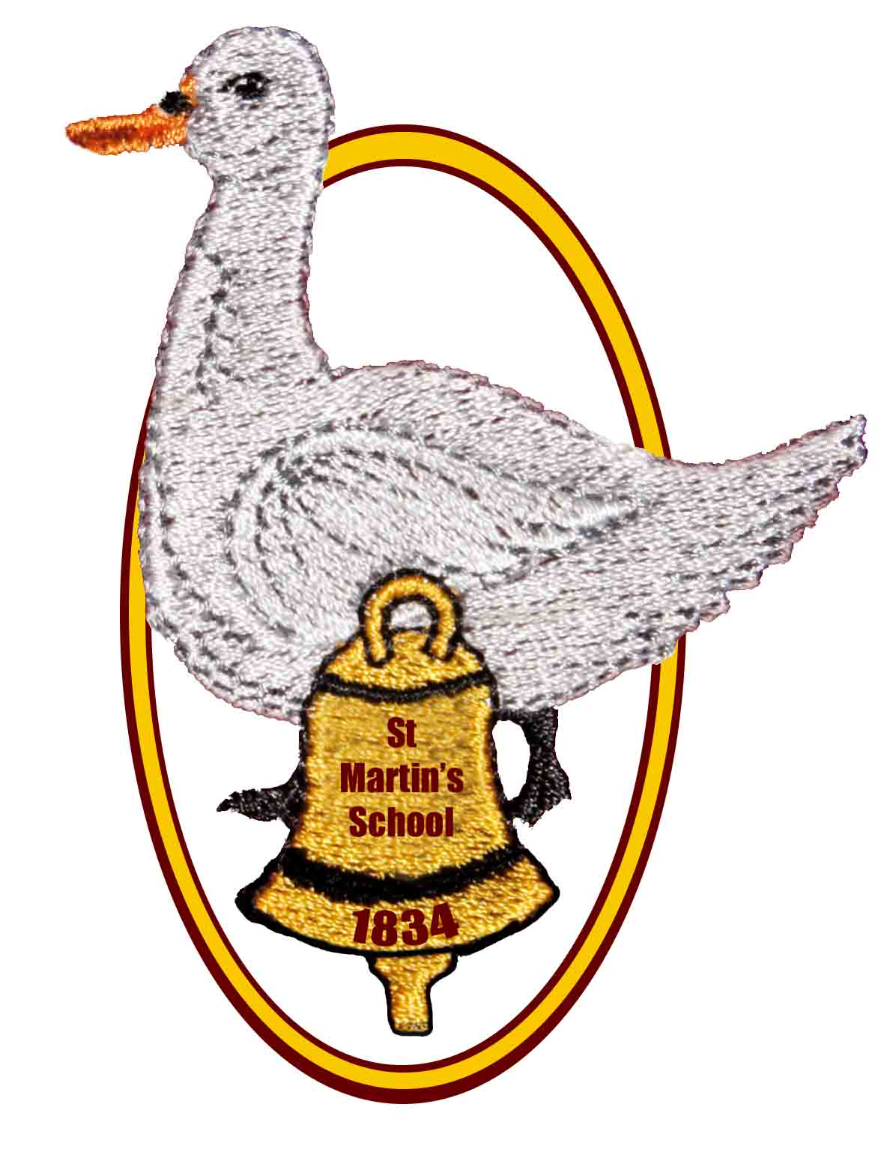
St Martin’s CE (Aided) Primary School

East End, Newbury, Berkshire RG20 0AF

Telephone: 01635 597796

E-mail: adminoffice@st-martins.hants.sch.uk

Headteacher: Mrs M Rennison

Uniform Policy

Status: Draft / Final

Date policy produced/reviewed: 30.06.26

Policy produced/reviewed by: Headteacher

Ratified by the governing body: 15.07.26

Signed:

Position:

Date of next review: September 29

St Martin’s CE (Aided) Primary School

Our School Vision
An inclusive, caring, Christian community, which inspires happy, confident and independent children who embrace lifelong learning, with the ambition and determination to achieve their potential. Learners develop the skills, knowledge and self-belief necessary to thrive, today and tomorrow, as global citizens, who strive to make God’s world a better place.

Uniform Policy

We believe that a uniform looks smart, is practical, contributes to a sense of belonging and identity and promotes the ethos of our school, as well as contributing to the health and safety of your child in the school environment. We actively encourage our children to wear school uniform and to take a pride in being part of the school community.

This policy has been developed, taking into account the Cost of School Uniforms DfE guidance Oct 25 https://www.gov.uk/government/publications/cost-of-school-uniforms/cost-of-school-uniforms which states that school policies should limit their number of branded items to 3 or fewer, and the Developing School Uniforms DfE guidance Nov 25 https://www.gov.uk/government/publications/school-uniform/school-uniforms.

Some of our uniform can be bought in high street shops, but school specific items need to be bought from Skoolkit, Kennet Centre, Newbury or at https://www.skoolkit.co.uk/. The only branded item required is the school sweatshirt or cardigan, however there are a number of other branded items that you can purchase should you wish to.

Uniform
*Maroon sweatshirt or cardigan with embroidered school logo
*White polo shirt, blouse or shirt
*Tailored grey school trousers, shorts, skirt or pinafore
*Black closed in school shoes or boots (no open toes, high heels, casual sandals or trainers) – black laces if laces required
*Green and white checked gingham dress or separates for the summer

Physical Education
*Black or navy shorts
*T-shirt or polo shirt in the correct house colour (North – Blue, South – Yellow, East – Red and West - Green)
*Black or navy jogging bottoms and sweatshirt or black or navy tracksuit for outdoor activities when it is cold
*Plimsolls or trainers that can be securely fastened
*A hair tie, if necessary (long hair must be tied back for all P.E. activities)

Other branded items available should you wish to purchase them
*White polo shirt
*Polo shirt in the correct house colour (North – Blue, South – Yellow, East – Red and West - Green)
*Reversible waterproof school jacket - for outdoor use only
*Bookbag
*Rucksack

Jewellery
For health and safety reasons jewellery is not permitted in school with the exception of:
- one stud earring in each ear, which should be removed by the child for P.E. or covered with tape brought from home;
- a watch with a clear display that your child can use (no novelty watches), which should be removed for P.E.
- A specific medical or religious reason
If you are considering having your child’s ears pierced, we would recommend that it is done at the start of the summer holidays, allowing time for the healing process and giving your child the opportunity to become familiar with removing and replacing the earrings. Please be aware that, on the grounds of health and safety, we are not permitted to remove or replace children’s earrings.

If your child needs to wear jewellery for medical or religious reasons please discuss this with the Headteacher.

Hair
All hair that is shoulder length or longer must be tied up.

Accessories
We encourage plain hair accessories for school. Make up, nail varnish and tattoos are not suitable for school.

Hats
Hats can be worn for warmth or sun protection as necessary during break times and lunchtimes outside.

Second Hand Uniform
We do not want our uniform policy to negatively impact on any of our families in terms of attendance, access, participation or bullying, and we do not want any parents or carers to have to worry about the prohibitive cost of uniform when choosing to apply to our school. We also consider sustainability and environmental impact when referencing uniform.
The school holds a selection of second-hand uniform, which is always available for a small donation to our school. Please contact the School Office if we can help.

Children at our school from the same family will always be in the same houses, therefore allowing for PE tops to be handed down to siblings in order to save costs of these.

Reasonable Adjustments
We recognise that for some children, particularly those with SEND, specific uniform items can cause discomfort, or some items may cause an issue due to religious beliefs. Should you feel that reasonable adjustments are needed for your child, please talk to the headteacher.

Non-uniform Days
Occasionally we will hold a non-uniform day, for example a dressing up day like World Book Day, or a non-uniform day in support of Anti-Bullying Week. We do not want these occasional days to be prohibitive to parents and carers in terms of cost. We will not ask parents and carers to purchase specific items related to specific days, and encourage parents and carers to talk to school staff about ways that these days can be catered for within home clothes or supported through school.

Political Impartiality
In order to ensure political impartiality, any clothing items, badges, flags, or any other visual references to political causes are not permitted in school.

All uniform must be clearly labelled with the child’s name.

