KS1 Spring 1 Homework Grid: Victorians
Please choose one activity a week, and record which activity has been completed by adding the date into the box provided. Please add comments, should you wish to, regarding your child’s engagement/enjoyment/understanding of each activity. Please choose at least one from each column during each half term.
English |  | Maths |  | Topic/Creative
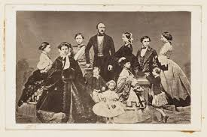  Using the internet, research Queen Victoria and her family. Choose a family member and create a fact file giving information about their life and achievements.  Year 1: Include key information about the person.  Year 2: Try and include some extra fun facts! | Date:  Comments: | 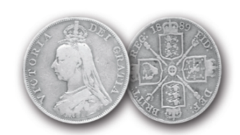  Money Compare coins from the Victorian era with our coins today. Can you draw and label some? | Date:  Comments: | The Victorians were excellent builders and engineers, building the first suspension bridges. Build a bridge using junk modelling and food items (e.g., sticks, toothpicks, spaghetti, marshmallows). | Date:  Comments:
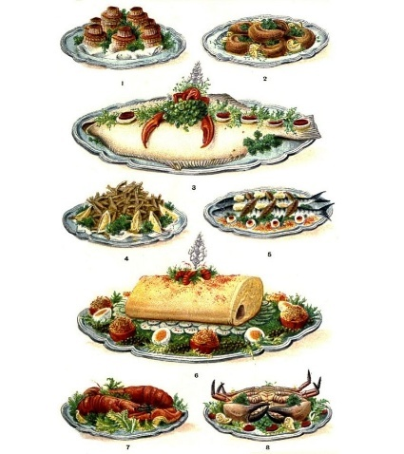  Research the different foods people ate in the Victorian era, use these to design a menu for a Victorian café or restaurant, you could also draw pictures of the different foods. | Date:  Comments: | Fractions investigation! Try to find 1/2 and 1/4 of different even numbers. Can you find 1/3 of different odd numbers? Use the dots and pots method to help you.  Year 1: Find 1/2 of different numbers.  Year 2: Find 1/2, 1/4, 2/4 and 1/3 of different numbers. | Date:  Comments: | Research, draw and label clothes from a poor Victorian child and a wealthy Victorian child. Think about differences and similarities to each other and compare to clothing nowadays. | Date:  Comments:
We know that life was hard for Victorian children and that many had to go to work. Write a job advert for a child in the Victorian times. Don’t forget to include a job description, responsibilities, dangers of the job and pay. Use writing and drawings.  Year 1: Create a poster advert, make sure it’s bold and colourful!  Year 2: Create a poster advert, try to include a range of punctuation. | Date:  Comments: | 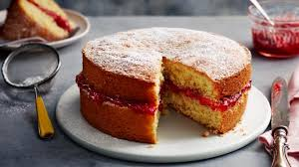  Use your maths measurement knowledge to weigh the ingredients and make a Victoria Sponge cake, take a photo or draw a picture. | Date:  Comments: | The Victorians loved dinosaurs and collecting fossils. Create your own dinosaur or fossil collage.  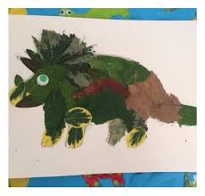 | Date:  Comments:
Research Victorian outdoor games and create an instruction manual for a game. Imagine you were writing it for someone who had never played the game before. You could play it with your family, see if they can follow your instructions!  Year 1: Draw pictures to show how to play.  Year 2: Write step-by-step instructions.  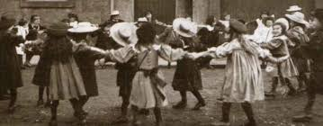 | Date:  Comments: | Time Practise telling the time on an analogue clock or watch.  Year 1: Read time to the o’clock and half past.  Year 2: Read time to the o’clock, half past, quarter past and quarter to  If you feel confident, why not try reading time to the 5 minutes! | Date:  Comments: | Draw and colour in a piece of artwork in the style of William Morris.  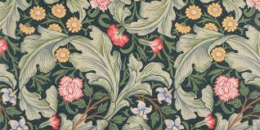  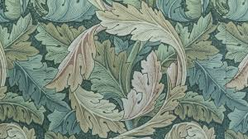 | Date:  Comments:

