The Maya!
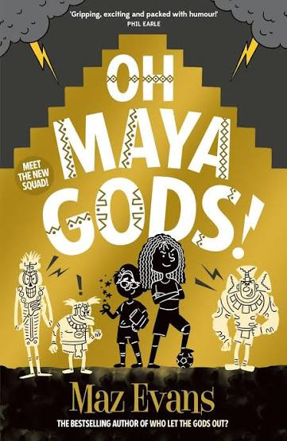

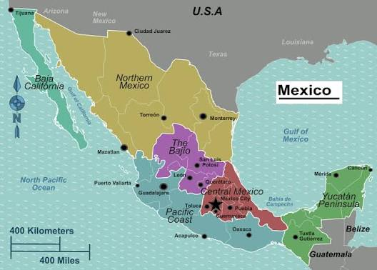

In English writing, we will be…
- Writing a recount linked to our class reader:
Oh Maya Gods!
- Researching and writing a non-fiction piece about The Maya.
- Practicing our writing skills by:
- Using paragraphing to structure our writing effectively.
- Using the correct form of address and formality relevant to the text type.
- Y5 – Using fronted adverbials to help set a scene.
- Y6 –Using adverbs of possibility to give our writing extra depth. Using a range of parenthesis to structure non-fiction writing.

In English reading, we will be…
- Exploring and analysing Maya Gods to develop our vocabulary and inspire our writing.
- Sharing in group reading and paired reading to practice our oracy skills.
- Examining and evaluating the features of information texts to help us plan and prepare our own.
- Using the different ‘Reading Roles’ to help us answer comprehension questions.

In our ‘English Grammar, Punctuation and Spelling’, we will be…
- Reviewing our previous learning including word classes.
- Y5 - Identifying modal verbs and adverbs, understanding relative pronouns and beginning to use relative clauses.
- Y6 – Identifying synonyms and antonyms and understanding the subjunctive form.
- Practicing Y5/6 spelling words focusing on words with double consonants: accommodate, accompany, according, aggressive, attached, embarrass, harass, occur, recommend.
- Y5 - Recapping words ending in: -er, -ar, -or, -re
- All – words ending in: -ary, -ory, -ery, -ly

In Mathematics, we will be…
- Place Value: Reading, writing, ordering and comparing numbers to at least 1,000,000 - determining the value of each digit (Y6 -10,000,000). Rounding any number up to 1,000,000 to the nearest 10, 100, 1000, 10,000 or 100,000 and using rounding to estimate solutions. Y6 - Rounding any number to a required degree of accuracy. Generating and describing linear number sequences.
- Calculations: Solving multi-step addition and subtraction problems in contexts using a range of representations and problem-solving skills. Deciding which operation and method to use and why. Identifying multiples and factors. Finding all factor pairs of a number, and common factors of two numbers. Knowing prime numbers to 20. Multiplying and dividing whole numbers mentally drawing on known facts. Multiplying and dividing part and whole numbers by 10 and 100. Y6 - Multiplying and dividing up to 4-digit numbers by a 2-digit number using a formal method.
- Fractions: Comparing and ordering, adding and subtracting fractions whose denominators are all multiples of the same number. Recognising and converting between mixed numbers and improper fractions. Y6 - Using equivalence and common multiples to simplify fractions. Comparing and ordering fractions, including >1. Adding and subtracting fractions, using the idea of common denominators to write equivalent fractions – using a bar model.
- Geometry: Identifying 3-D shapes including cubes and other cuboids from2-D representations (nets). Y6 - Comparing and classifying shapes based on properties, angles and symmetry. Illustrating and naming parts of the circle (radius, diameter, and circumference).

In Science, we will be…
- Understanding what fossils are and how they can help use track geological time and classify

In Geography and History, we will be…
- Using maps and atlases to locate Mexico and its features. Exploring and researching The Mayan civilization.

In Art and DT, we will be…
- Exploring Mexican Street Artists and creating our own interpretations.
- Researching, preparing and cooking our own Mexican dishes.

In PSHCE and Computing, we will be…
- Working collaboratively to write our class charter. Exploring how we stay safe, including online through a focus on e-safety.

In French, we will be…

Continuing to learn a range of interactions, vocabulary linked to returning to school and important dates.

In Music, we will be…
- Investigating the dynamics, tempo and structure of South American Music

In RE, we will be…
- Kingdom of God: What kind of king is Jesus Christ?
In PE, we will be…
Gym (indoor) floor work. Working on our invasion game skills in netball.

In Computing, we will be…
- Revisiting our IT agreement rules and what it means to work safely online.

This term’s vocabulary will be…
Science – fossil, evolution, sedimentary, igneous, metamorphic, palaeontologist, organism, microorganism, bacteria, extinct
History/Geography – stelae, maize, maize God, hieroglyphic, pyramid, calendar, warrior, priest,

