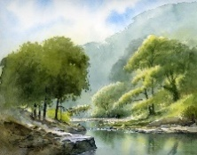
Willow Homework Grid: Rivers
I I did this independently with no help.
S I did this with some support.
H I needed lots of help and found it tricky.

English |  | Maths |  | Topic/Creative
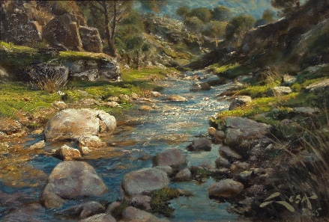  Writing:  Use this visual stimulus to write a description of the river and its surroundings. Imagine you are in the picture to help you think of descriptive vocabulary. Can you use similes and expanded noun phrases? Can you use your senses to describe what you can see, hear, feel, smell, etc?  Y6: Can you create an atmosphere of peace and tranquillity using detailed descriptions? | Date:  Comments: | Place Value, Number and Calculations:  Y5: Write a 7-digit number.  Y6: Write an 8-digit number.  a) Write the number in words.  b) Write the number in expanded form.  c) What is the value of the tens digit, thousands digit and hundred thousands digit?  d) Write the new number when you x10 x100 x1000.  e) Write the new number when you ÷10 ÷100 ÷1000.  f) Double the number.  g) Half the number.  h) What other maths skill can you use with your number?!  PLEASE COMPLETE AFTER WEEK 2! | Date:  Comments: | 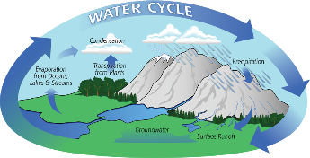  Science activity: Choose your own activity!  1) Create an explanation video on ‘How the water cycle works’. Pretend you are an expert on the subject and get someone to film you explain what happens in the water cycle. You could use diagrams, posters, props, role play, other adults/siblings, etc to help you create your own documentary-style video. Ask an adult to email the office your completed video to pass on to me.  2) Find out what these words mean and create a picture glossary to define the words. Solid, liquid, gas, melt, freeze, heat, cool, thermometer, temperature, evaporation, condensation, precipitation, transpiration, etc. | Date:  Comments:
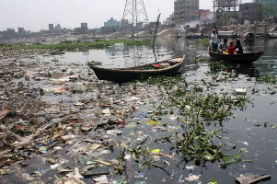  Writing:  Write a poem with the title ‘I am a river’.  Y6: Can you include figurative language such as similes, metaphors, personification, etc?  Use the following website to inspire you: https://www.conservation.org/nature-is-speaking | Date:  Comments: | Statistics:  Find out the lengths of 10 famous rivers. Create a bar chart showing their lengths. Don’t forget to use a ruler, label the axes, use the correct unit of measure (miles or km) and give your bar chart a title.  Y6: Can you write a challenging multi-step question about your graph? | Date:  Comments: | 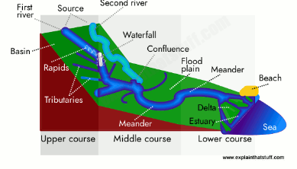  Geography: Choose your own activity!  1) Make a river diorama using junk modelling.  2) Draw a diagram of a river system labelling the features of the river. Label these on your diagram or diorama: source, mouth, estuary, delta, erosion, meander, floodplain, ox-bow lake, tributary, channel, etc. | Date:  Comments:
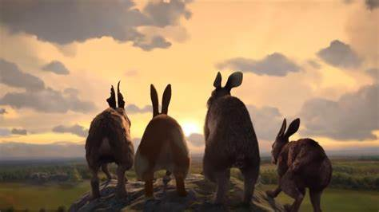  Reading:  Design a front cover for the traditional novel we are reading, Watership Down, to show your understanding of what the story is about.  Y6: Can you capture the difference between the main characters in your drawings?  PLEASE COMPLETE AFTER WEEK 4! | Date:  Comments: | Mental Maths:  Make a ‘Times Tables Tips’ poster for your bedroom. Show quick strategies / tricks for remembering the multiplication facts for x0 to x12.  Y6: Present quick ways of working out ?x13, ?x15, ?x20, ?x5, ?x0.1 and ?x0.5 mentally. | Date:  Comments: | 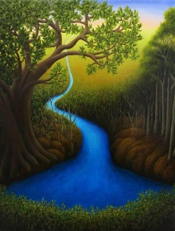  Art:  Create a drawing/painting of a river showing the landscape including the sky, the trees, mountains/hills, pebbles in the water and the river itself. You could sketch it or use water colour paints, crayons, colouring pencils, felt-tips or mixed mediums to colour it. | Date:  Comments:
Spelling Practice:  Make your own spellings crossword using the first 15 Y5/Y6 words (accommodate to bruise). Remember your clues can be synonyms of the word, a definition of the word or a sentence with the word missing. Spellings: accommodate, accompany, according, achieve, aggressive, amateur, ancient, apparent, appreciate, attached, available, average, awkward, bargain and bruise. | Date:  Comments: | Place Value / Rounding Practice:  Y5: Answer the place value questions about rounding numbers to the nearest 10, 100, 1,000, 10,000 and 100,000 on Purple Mash.  Y6: Answer the different place value questions.  The tasks have been set as a ‘2Do’ for you, but please make sure your login details are set-up before you do this homework! | Date:  Comments: | PSCHE / Family Discussion activity:  With your family, discuss how you individually show the following emotions: anger, excitement, exhaustion, anxious, stress, joy, etc. Do some of you have a more effective way of showing this emotion? Discuss different strategies for managing these emotions in your own family and the wider world. | Date:  Comments:

