Cherry Class
Autumn Term 1 2022
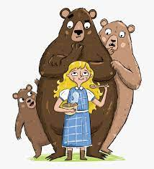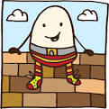

Bears and Rhymes

Here is a summary of our planned learning for this half-term. But remember:
No plan in Reception is ‘set in stone’!

Communication, Language and Literacy
We’re going on a Bear Hunt
Goldilocks and the Three Bears
Get well card for Humpty Dumpty
Peace at Last – listening skills
Hog the Hedge initial sounds

Mathematics
Subitise to 3 (recognise quantities without counting)
Numbers in the environment
Number rhymes
More/less
Patterns – sorting bears

Physical Development
Funky fingers/dough disco/tracing/planting Humpty cress
Cutting skills – bears and Humpty
Using tools safely for making beds
PE Games: Beanbags

Understanding the World
Bear Hunt in the Nature Area
Growing cress for Humpty
Changes in Season – Autumn/conkers
Old and new bears
Use Purple Mash to draw a bear on the computer

Expressive Arts and Design
Painting themselves
1,2,3,4,5 fish printing
Drawing and painting bears
Bear Hunt music

Personal, Social and Emotional Development
All About Me – starting school
Class charter: rule and routines.

RE
Welcome - We are unique and special
School Values
Worship Time

