
Willow Homework Grid: Welcome to Wales!
I I did this independently with no help.
S I did this with some support.
H I needed lots of help and found it tricky.

English |  | Maths |  | Topic/Creative
Writing:  - Many famous Welsh writers were inspired by the landscape in which they lived. Can you write a descriptive poem inspired by a landscape that you know well?  - Choose a holiday destination in Wales – perhaps one you’ve been to yourself (if you haven’t travelled to Wales choose one that you know from our class work). Write a postcard from your destination that might convince someone to holiday there. | Date:  Comments: | Place Value:  Take a large number – over 1,000,000  Can you use 3 different methods – including at least one well-presented drawing - to show your understanding of partitioning numbers this size?  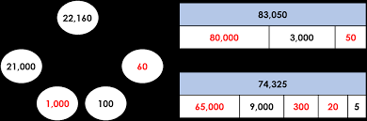 | Date:  Comments: | History: This term we will explore aspects of Stone age and Iron age life.  Using historical fact as the basis (research if you need to) can you write a diary from the perspective of a person alive at the time?  Include realistic aspects of their life. | Date:  Comments:
 |  |  |  | Art and Design:  Carved wooden ‘Love Spoons’ are a Welsh craft tradition.  Use the internet to research the symbolism of the different patterns used and design your own spoon handle. | Date:  Comments :
Writing:  Make a video, PowerPoint or poster to explain one of these grammatical terms or types of punctuation:  - Passive and active voice  - Semi-colon vs colon use  - Using commas for clarity  Make sure you research your answer and are sure you’re on the right track! | Date:  Comments: | Calculations:  Take a week to fully focus on your times tables or arithmetic skills.  There are plenty of good exercises on www.myminimaths.co.uk which you could use.  Y6 should focus on long multiplication and long division.  This is a bar modelling challenge, can you use bar modelling to solve it?  Harry and Meg have some roses.  3/10 of the flowers are red roses, the rest are white roses.  Harry gives 50% of the white roses away and buys 17 more red roses.  They now have 121 roses in total. How many roses did they have at the start? | Date:  Comments:
 |  |  |  | DT:  Cook some traditional Welsh food with your family. What did you cook? Did you enjoy it?  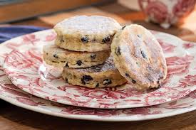 | Date:  Comments:
Reading:  Research a famous Welsh person. Can you write a short (one page) biography of their life?  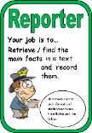  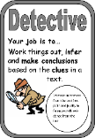 | Date:  Comments:
 |  |  |  | PSCHE / Family Discussion activity:  Family Origins:  Share stories about the family's nationality or nationalities. Use family photos to illustrate if possible. Explain where your family comes from and any traditions or cultural practices that are important.  Ask each family member to think about their own nationality and what it means to them. Encourage them to ask questions about their heritage. | Date:  Comments:
 |  | Statistics:  Conduct a survey on a topic of your choice and create a pie chart to display your results. Hand draw your chart using a ruler, compass and protractor.  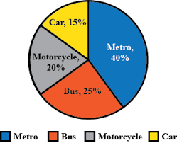 | Date:  Comments:
Spelling Practice:  Take some time to look at the word list in the back of your homework diary. Which words do you need to focus on for spelling? Take some time to focus on learning these (You could use the spelling techniques we learnt in class),  Write 6 sentences using at least one word per sentence. | Date:  Comments:
Date:

Comments:

