St Martin’s CE (Aided) Primary School

Year 5/6 Residential Visit to Liddington

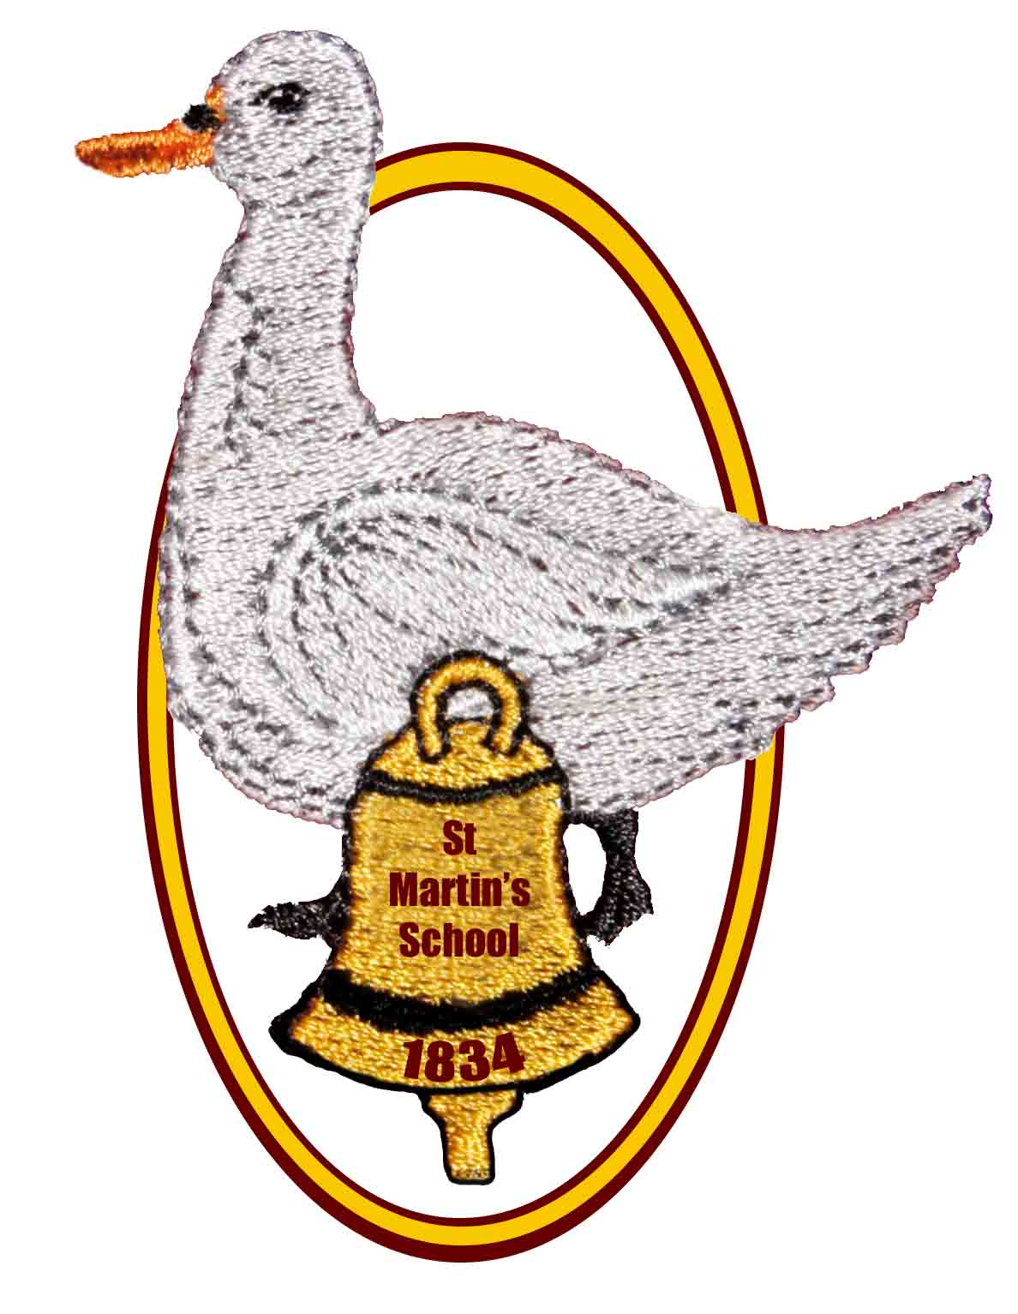

Dates
Monday 20th October – Thursday 23rd October

Accommodation
PGL Liddington
Foxhill
Liddington
Swindon
SN4 0DZ
0333 321 2100

If for any reason you need to contact us please ring the
School Office on 01635 597796.

If the School Office is closed the school emergency
phone number is 07979 645471

Key Information

Staffing

Trip Leader: Mrs Rennison – full trip

Other Staff: Ms Mendivil – full trip
Miss Payne – full trip
Mrs Hopkinson - Tuesday and Wednesday days

Travel
We will be travelling by fully seat-belted coaches from a Hampshire approved company. We aim to leave school at approximately 9:30am on Monday 20th October. Last year we found that it worked really well with the children waiting in their classroom until we were ready to go – being around friends and the staff going on the trip helped calm down the few children who were a little wobbly about leaving parents and meant that when we got on the coach they were all excited about going.

However, we recognise the importance of you being able to wave your child off, both for your child and for you! Therefore, we ask you to arrive at school between 8:30am and 9:00am, leave their suitcase by the gate, bring your child to the school hall and say goodbye to your children at the hall door. They will go across to their classroom to wait until we are ready to leave. The classroom staff will be there to look after any that are feeling a little nervous, and chatting with their friends always helps to move the focus from anxiety to excitement! If you would then like to, you can go onto the school field and wait for our departure. In order to respect our neighbours, we ask that you do not wait out in the road. As soon as we are ready (there is various paperwork that cannot be completed until all the children have arrived), we will collect their luggage from the hall and walk to the coach, and you will then be able to wave us off from the school field.

We aim to return to school at about 3:00pm on Thursday 23rd October. We will let school know if we are delayed at all. Please can you wait for your child in the school hall. When we arrive back we will all walk into the hall, where you can give your child a big hug and welcome them back, while we check everyone has all their things, speak to any parents we need to speak to and hand back any medication or boxes. You can then go and enjoy half term (Friday 24th October is an INSET day)!

Catering
All food, except lunch on arrival, will be provided by Liddington. If necessary, please ensure you have completed the Special Diet form and return it to school by Monday 29th September.
Please ensure that your child brings a packed lunch for the first day.

Equipment
All items must be clearly named, including footwear.
It is advisable to keep old worn out clothes for certain residential activities.
Each child will require the following items for four days:
Cuddly toy
2 pairs of sturdy trainers or walking shoes
1 pair of shoes for water activities e.g. old trainers, waterproof shoes, crocs
1 pair of indoor shoes (practical slippers or plimsolls)
Fully waterproof cagoule with a hood
Waterproof trousers
Thermal fleece or coat
Mittens or gloves, woolly hat, scarf
4 - 5 warm jumpers/sweatshirts
4 - 5 pairs of trousers/jogging bottoms (please avoid jeans as these do not dry quickly)
4 - 5 shirts/t-shirts (please avoid strappy tops which do not cover shoulders)
Pyjamas and dressing gown
Changes of underwear and socks (not trainer socks) for 4 days and a spare
1 towel for showering and 1 old towel for wet activities
Wash bag and toiletries (no aerosols please)
Glasses and case for those who wear them
A book
A small game
Pencil case
Large plastic bags for dirty clothes and shoes
Stamped, addressed envelope to send home (if children want to)
A packed lunch for the first day

Please leave jewellery at home as we don’t want anything lost.

Binoculars and Cameras
Children may bring a pair of binoculars and/or a camera but these are their responsibility to look after.

Mobile Phones
Please do not send mobile phones on the trip as this tends to make any home sickness issues worse rather than better and always runs the risk of them being lost. All staff will have mobile phones in case of emergency. If a child is really homesick and we think it may ease the child’s worries, we may let them use a staff phone to contact home, but we will use our discretion around this in case we think it will make things worse. In all situations we will do what we feel is best for your child.

Electronic Games, MP3 Players, Ipads etc
Please do not send electronic games or devices including music players. There will be plenty to keep them busy and again these may get lost or broken.

Spending Money
The children may bring a maximum of £10 for the week. This should be in pound coins and handed in to the office by Monday 29th September in a named envelope or wallet.

Medicines
Any medicines (including sun cream) should be named and put in a zippy wallet with a completed medication form giving details of instructions and dosage. If possible, this needs to be handed to the school office by Monday 29th September – any last-minute changes can be made on Monday 20th October before departure. If you wish to discuss your child’s medical needs any further, please do not hesitate to contact the school office to arrange a meeting.

Cakes
There is a tradition at St Martin’s of Year 6 parents providing cakes for the residential. If you would like to provide a cake for the children to share during the residential, it will be greatly appreciated by both the children and the staff on the residential! In order to ensure that we are not putting anybody at risk, please could we ask that you include a list of ingredients with any cake that you send. As you are aware, we are a nut free school, so please ensure that there are no nuts or nut-based products in any cake, either made or bought. If you want to send a cake, please send the cake and ingredients list in a suitable container. If you would like us to return your container, please ensure it is clearly labelled with your child’s name. We will endeavour to get these back to you when you pick up your child.

Sweets
The children should not bring any sweets with them for the week.

Updates
Each day we will try to share our achievements with you through the school Facebook group and the news section on the school website. Please be aware that this does rely on us having good internet connection, and also the time to do this; at all times, the children’s welfare comes first so if we are working on settling children during the evenings, updates may be later. However, please rest assured that should there be a problem, we will contact you.

