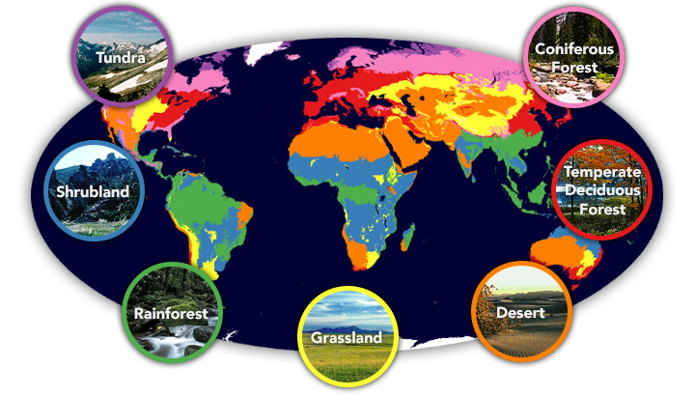
Home, Sweet Biome

In English, we will be…
- Writing narratives including descriptions of a story setting using examples from ‘The Hobbit’, ‘Harry Potter’ and ‘The Explorer’.
- Using the appropriate genre features and showing an awareness of the reader.
  - Using figurative language such similes, metaphors, onomatopoeia and personification and language that describes the mood and atmosphere of a setting.
  - Varying sentence structures and using a variety of punctuation for parentheses such as dashes, brackets and commas to add in relative clauses.
  - Using a range of cohesive devices to achieve flow and cohesion.
- Writing persuasive leaflets to reduce plastic waste.
- Writing balanced arguments / discussion texts on themes involving our world and its future.
  - Discussing controversial issues and contributing ‘for and against’ arguments.
  - Evaluating discussion texts and their purpose.
  - Using a range of conjunctions.
- Using organisational and presentation skills to make the most impact on the reader.
- Y6: Using the correct punctuation for effect.
- Y5: Using the appropriate formal and informal tone according to the genre.
- Developing our skills of self-editing and peer-editing.

In our reading, we will be…
- Identifying features of persuasive texts and balanced arguments.
- Exploring the ways in which grammar, punctuation and vocabulary can be used for effect.
- Using our ‘Reading Roles’ to help us retrieve, infer, define unfamiliar words, deduce and analyse author choices.

In our ‘English Grammar, Punctuation and Spelling’ we will be…

Reviewing our knowledge of all word classes. Y5: determiners, pronouns, conjunctions and adverbials.

Reviewing our knowledge of punctuation functions. Y6: semi-colons, colons and hyphens.

Learning the simple, progressive and perfect verb tenses.
- Y6: Understanding subject and object, passive and active and the subjunctive form.

In Mathematics we will be…
- Place Value: Understanding negative numbers in context, using multiplication and division facts and rounding large numbers and decimal numbers. Y6: Place value SATs questions.
- Geometry: Identifying 3-D shapes including cubes and other cuboids from 2-D representations (nets).
Comparing and classifying shapes based on properties, angles and symmetry. Finding unknown angles in shapes (triangles, quadrilaterals and regular polygons). Y6: Identify parts of the circle (radius, diameter and circumference).
- Y6 Algebra: Expressing missing number problems algebraically. Using simple formulae to solve problems
generating and describing linear number sequences.
- Calculations: Practising mental strategies for all four operations and using problem solving and reasoning to apply our skills in using the written methods for all four operations. Y6: Order of operations revision.
- Fractions: Adding and subtracting fractions. Recognising equivalent fractions, decimals and percentages. Y6: Multiplying and dividing fractions.
- Y5 Problem solving: Applying mathematical skills to solve problems and listing all possibilities.
- Y6 Ratio and Proportion: Calculating the ratio and proportion and solving reasoning problems.
- Y6: Developing pace and accuracy when answering SATS style questions and arithmetic practice.

In Science, our topic will be…
- Learning about living things and their environment, identifying organisms and their habitats.

In Design Technology, we will be…
- Designing, making, adapting and evaluating a healthy, environmentally friendly snack.

In PSHE, we will be…

Discussing the wider world and global issues.

In Geography, we will be…
- Using our location knowledge to identify longitude, latitude, etc. on a world map.
- Describing key aspects of different biomes.
- Studying the physical and human geography of a key region in South America.

In French, our topic will be…

Learning to name and describe animals (Mrs Bartlett).

In Music, we will be…

Learning about musical notation and producing music inspired by animals (Mrs Rennison).

In RE, our topic will be…

Learning about communities and how these are viewed in Islam and Buddhism (Mrs Bartlett).

In PE, our topic will be…
- Playing invasion games with a focus on netball and basketball (Mr Bint).
- Working on shape and balance through gymnastics (Mrs Bartlett).

In Computing, we will be…
- Using logical reasoning to solve problems in simulation programs.
Our key science/geography vocabulary this term will be…
Biomes: biodiversity, boreal forest/Taiga, climate, coniferous forest, continent, climate, deciduous forest, deforestation, desert, ecosystem, environment, equator, flora, forest, global, habitats, humidity, latitude, location, longitude, pollution, rainforest, savanna, season, temperate, temperature, tundra, vegetation belt, weather, etc.

