English |  | Maths |  | Topic/Creative
Draw or photograph your favourite toy. Label its features. Use expanded noun phrases to write a description of your toy. Remember your common exception words and punctuation. | Date:  Comments: | Toy Shop: Set up your own toy shop at home! Give some of your toys price tags. Take turns with a family member to be the shopkeeper and the customer. Buy an item and find the correct coins needed to pay. Can you buy more than one item and add them together to find the total? | Date:  Comments: | Sorting: Sort your toys into groups. You can decide your own criteria such as new and old, wheels or no wheels or electronic and non-electronic. You could take a picture of your sorting to bring into school or write your results in a diagram. Remember to label the sets. | Date:  Comments:
Design a poster for your dream toy. Make it eye catching and include information about the toy. Write a description of the toy, what it does and why people should buy it.  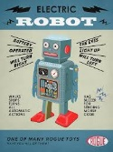 | Date:  Comments: | 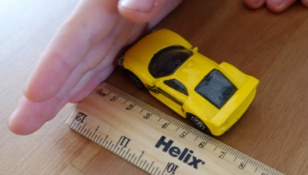  Using a Ruler: Measure some of your toys to the nearest centimetre using a ruler. Put them in order from the longest to the shortest. What is the difference between the longest and shortest toy? | Date:  Comments: | Toys in the Past: What did Mum and Dad or Grandad and Grandma have as toys when they were children? What was made from? Can you still buy it today?  Interview your family and find out what they used to play with. You can record this in whichever way you like.  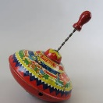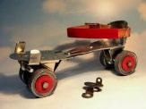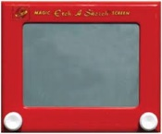 | Date:  Comments:
Think of similes to describe your toys, e.g. as fast as a rocket, soft like a cushion, as furry as a kitten.   | Date:  Comments: | 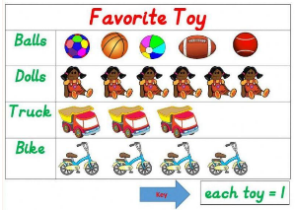  Making a Graph: Choose 4 toys. Ask your family and friends what their favourite toy is from your list. Make a tally chart. Then draw a pictogram about the favourite toys. | Date:  Comments: | 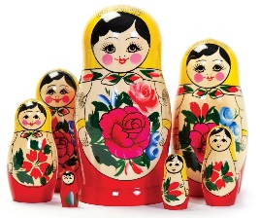  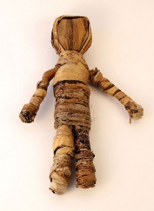  Toys from around the World: Choose a country. Research the toys children play with there. | Date:  Comments:
  Using your toys create a movie! You will need to think of a plot and the characters. You can ask your grown up to film it and email it to us so we can watch! | Date:  Comments: | 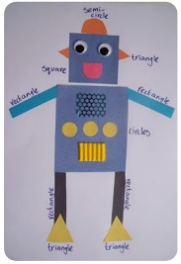  Shape Robot: Cut out some 2D shapes. Create a toy robot. Label it with the 2D shape names. Extra challenge - can you make your robot symmetrical? | Date:  Comments: | Design and build a 3D toy model from junk or construction! Can you make it move?  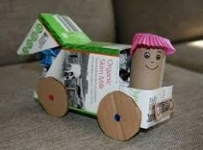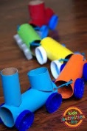 | Date:  Comments:
Homework Grid Autumn 2
Please choose one activity a week, and record which activity has been completed by adding the date into the box provided. Please add comments, should you wish to, regarding your child’s engagement/enjoyment/understanding of each activity. Please choose at least two from each column during each half term.

