Homework Grid Summer 2: Our World!
English |  | Maths |  | Topic/Creative
Research a person of significance who has links to Newbury. Create a personal profile including information about their life e.g. what they are famous for, their achievements and other interesting facts.  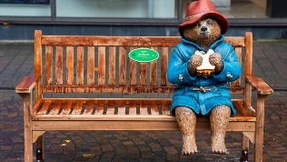 | Date:  Comments: | 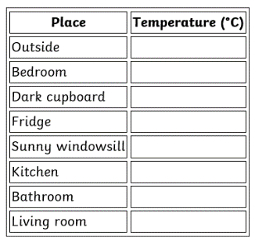  Using a thermometer, measure the temperature of different places around your home (e.g. outside, in your bedroom, dark cupboard, fridge). Draw a table with your answers. | Date:  Comments: | 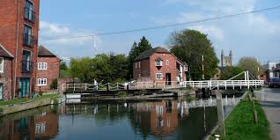  Find places of historical interest. Go for a walk around your local area or town. Take photos of places of historical interest. Print these photos and add a caption to each one. | Date:  Comments:
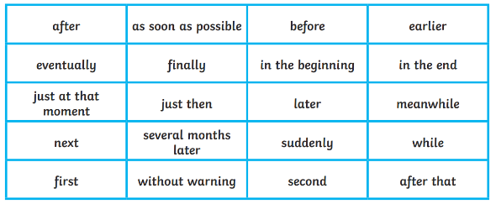  Write a recount about your weekend. Extend your sentences with the conjunctions: and, but, because, so. Add noun phrases, descriptive language and time connectives (see below). | Date:  Comments: | Describe the directions you take on a short familiar local journey using mathematical language - left, right, clockwise, anti-clockwise, quarter turn, half turn and three-quarter turns. Draw the route you took including landmarks.  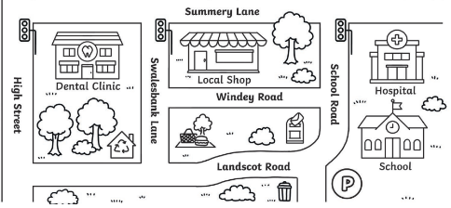 | Date:  Comments: | 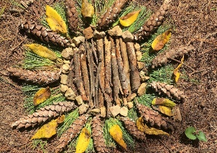  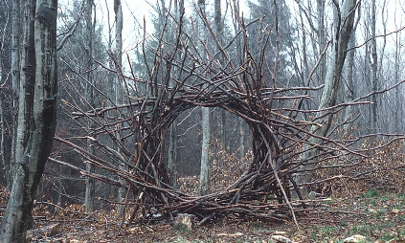  Create a 3D sculpture or 2D land art in the style of Andy Goldsworthy using natural materials you can find in your garden or woodland area. Take a photo of your artwork. | Date:  Comments:
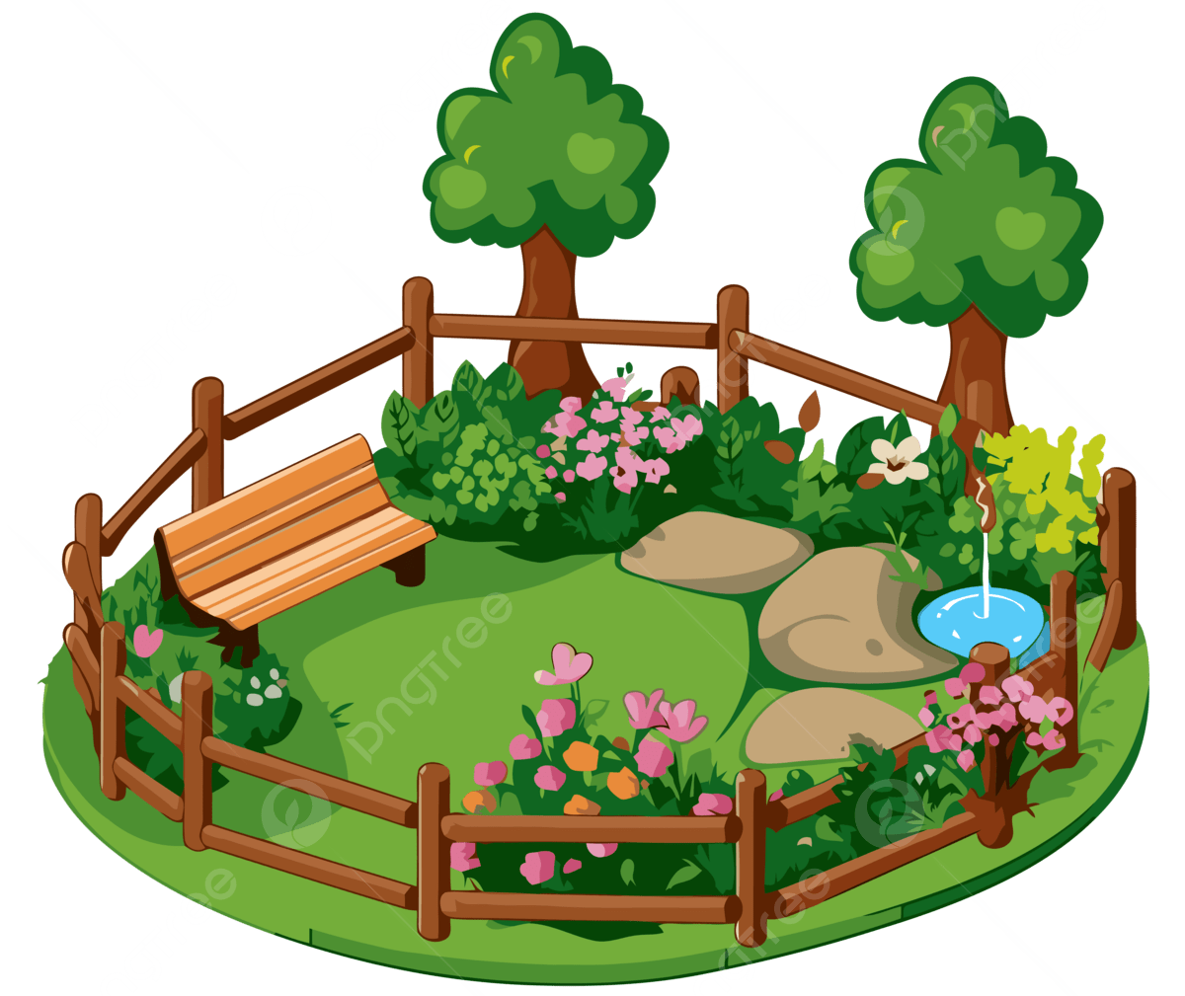  Take a photo of your garden or a place of beauty in your local area. Write a letter to someone who has never been there about where you are and why you like it. Include detailed reasons including descriptive words and your senses. | Date:  Comments: | 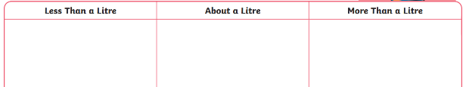  Be a capacity detective. Search for containers in your house/garden. Sort them into groups titled: greater than, smaller than, equal to 1 litre. Write the name of the container and its capacity in your book or take a photo of the labelled groups. | Date:  Comments: |   Compose a piece of music about the world. You can write a song with words or simply use one or more instruments to make up a piece of music. Record it. | Date:  Comments:
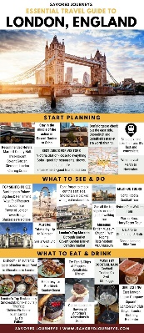  Choose a city or country. Create your own travel brochure. Think about all the things you would like to include:  - different attractions you like to visit  - places you like to eat  - shops you like to visit  - pictures  - maps | Date:  Comments: | Hit the Button!  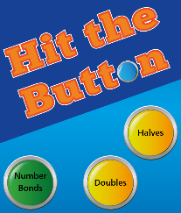  https://www.topmarks.co.uk/maths-games/hit-the-button  doubles and halves and number bonds plus  2s, 5s, 10s  Practise your maths skills online! | Date:  Comments: | Make your own sports game    Consider whether it is a team sport, what equipment you will need and what the rules of the game are. Draw and label a picture of your game. Write what it is about. | Date:  Comments:
Please choose one activity a week, and record which activity has been completed by adding the date into the box provided. Please add comments, should you wish to, regarding your child’s engagement/enjoyment/understanding of each activity. Please choose at least two from each column during each half term.

