Willow Homework Grid: ‘Ancient Greeks’
I I did this independently with no help.
S I did this with some support.
H I needed lots of help and found it tricky.

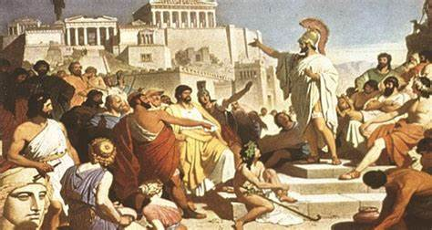
Please choose one activity a week, and record which activity has been completed by adding the date into the box provided. Please add comments, should you wish to,
regarding your child’s engagement/enjoyment/understanding of each activity. Please choose at least two from each column during each half term.
English |  | Maths |  | Topic/Creative
Reading:  Research and read two different Greek myths. Then, complete the following table in your book.  Myth 1 Myth 2  Hero / heroine?  Danger / problem?  Villain / mythical beast?  Resolution / tragic ending?  Favourite words/ phrases  Y6: Using the similarities between the stories, make a list of WMG Greek Myths. | Date:  Comments: | 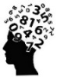  Calculations:  Use written methods to work these out.  Y5: a) 56783+47668 b) 78406-34883 c) 8563x67 d) 6486x84 e) 6784÷4 f) 7894÷6.  Y6: a) 567.83+4.7668 b) 784.06-348.83 c) 85.63x6.7 d) 6.486x8.4 e) 6784÷14 f) 7894÷36  Y6 Tips: For + and - line up the decimals. For x, you need to count the swoops, then put the decimal point in at the end. For ÷, write the multiples first to help you!  PLEASE COMPLETE AFTER WEEK 2! | Date:  Comments: | 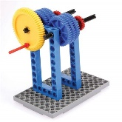  Science activity:  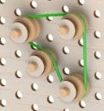  Explore and create different gears, levers and pulleys. You could use a construction set such as Lego or junk modelling materials. How do they work? Can you draw a labelled diagram or take a photo of your model?  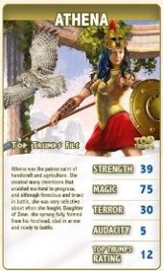  History: Choose your own activity!  1) Make some Greek gods and goddesses top trump cards. Research the different gods and goddesses and find out what they are rulers of, what powers they possess, whether they are good or evil, etc. Then, rank them and use scores to create a card for each one.  2) You could make Greek mythical beasts top trump cards instead and include ratings for strength, weakness, ability, magic and terror.  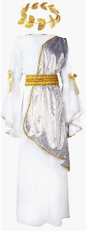  Art and Design:  Design your outfit for ‘Ancient Greek Day’. Maybe you could be a goddess/god /mythical beast/a Spartan soldier/an Athens scholar/a hero/ heroine/ Alexander the Great. Try and use materials from around the house or junk modelling and create an accessory to go with your outfit such as a headdress, shield, jewellery or a helmet.  PSCHE / Family Discussion activity:  As a family, discuss things that you do to keep healthy under the following topics: teeth, diet, exercise, sleep and mental health. Is there anything that individually or as a family you need to get better at? Discuss one change you could all make that could benefit your health. | Date:  Comments:  Date:  Comments:  Date:  Comments:  Date:  Comments:
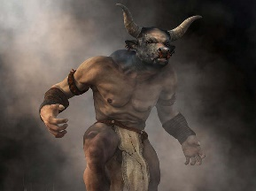  Writing:  Either research a Greek mythical beast such as Echidna, Chimera, Hydra, Cerberus, Medusa, Scylla, Minotaur or create your own mythical beast. Draw the mythical beast and then label it with descriptive vocabulary using expanded noun phrases, similes, metaphors, personification, etc. Think about its appearance, its abilities, its personality and even its history and how it became a beast. | Date:  Comments: | 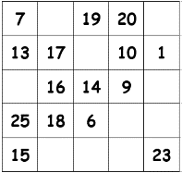  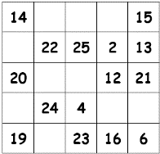  Mental Maths:  Complete the magic squares using mental addition and subtraction.  Y5: Write the numbers 1-25 in the squares, so that each row, column, and diagonal add up to 65.  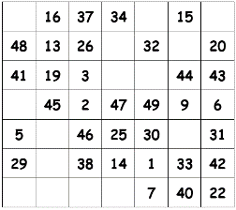  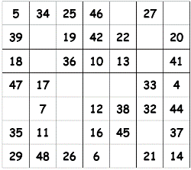  Y6: Write the numbers 1-49 in the squares, so that each row, column, and diagonal add up to 175. | Date:  Comments:
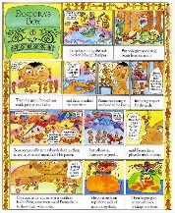  Writing:  Create a storyboard / comic strip retelling your favourite Greek myth. Try to use narration boxes that include fronted adverbials or setting descriptions, use speech bubbles and thought bubbles and ensure the story has a build-up, problem, climax and resolution. | Date:  Comments:
 |  | 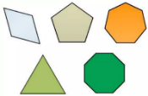  Shape:  Research, draw and label the following 2D shapes with the number of sides, vertices, and the name of the shape. Pentagon, hexagon, heptagon, octagon, nonagon, decagon, triangles (equilateral, scalene, isosceles) and quadrilaterals (rectangle, rhombus, kite, trapezium, parallelogram, and irregular quadrilateral.  Y5: Mark the acute, obtuse and reflex angles on the shape.  Y6: Write the total of the interior angles in a quadrilateral, triangle, pentagon, hexagon, heptagon, and octagon. | Date:  Comments:
Spelling Practice:  Make your own spellings crossword or a word search using 13 of the Y5/Y6 words (category to curiosity). Remember your clues can be synonyms of the word, a definition of the word or a sentence with the word missing. For the word search, still use definitions! Spellings: category, cemetery, committee, communicate, community, competition, conscience, conscious, controversy, convenience, correspond, criticise and curiosity. | Date:  Comments:
 |  | 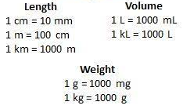  Measures:  Complete the Purple Mash converting units of measure activities. The task has been set as a ‘2Do’ for you. | Date:  Comments:

