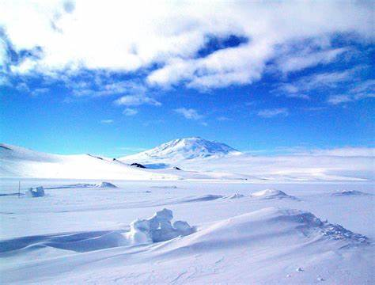
Let it Snow!
Sycamore Class
Spring 1 2026
English
Writing
- Polar-themed texts
- Key skills – Focusing on using a range of sentence types, as well as conjunctions (and, because, when, if, so, but).
- Handwriting – continuing to focus on joined hand-writing, thinking about the size of our writing and the relationship between the lower-case and upper-case letters.
- Spelling - building on existing phonics knowledge and introducing alternative sounds as well learning new spelling rules and patterns.
- Practise writing our common exception words.
Reading
- Whole class / small group reading activities linked to our theme, focus texts and other similar texts.
- Continuing to use our phonic skills to decode new words and use word patterns to help us with this (linked to spelling).
- Listening to our own reading, checking the text makes sense and correcting it.
- Focusing on our inference skills, and the author’s use of language for effect.
- Begin to explain the different ways non-fiction books are structured.

Mathematics
- Place Value – count forwards and backwards to 100 in 1s, 2s, 3s, 5s, 10s. Continue to embed an understanding of 2-digit numbers.
- Addition / Subtraction – add and subtract 2-digit numbers with and without bridging (crossing a ten), using concrete objects, pictorial representations and mentally.
- Multiplication and Division – represent and use multiplication and division facts for 2s, 5s and 10s times tables.
- Problem Solving – solve numeracy and time problems in context, using concrete objects and pictorial representations.
- Fractions – find fractions (1/3, 1/4) of shapes.
- Geometry – identify and describe the properties of 2D and 3D shapes.
- Measures – estimate, measure and compare mass using digital scales.
- Time – recall the number of minutes in an hour and hours in a day. Tell and draw the time on clock faces: o’clock, half past, quarter past and quarter to.
- Statistics – interpret and construct simple pictograms and tally charts by asking and answering simple questions.

Science: Plants
- Identify garden and wild plants.
- Identify a range of trees.
- Name the different parts of a plant and their function.
- Make observations of growing plants.

Geography: Explore the Polar Regions
- Knowing:
  - Where it is in the world
  - Which countries are in the Arctic Circle
  - Climate in the Polar Regions
  - Physical features
  - Towns and cities in the Arctic and compare to a city in the UK

RE: Belonging in Judaism – The Shabbat
- Recognise that Jewish people show they belong to the Jewish faith by celebrating the Shabbat and remembering creation and the day of rest.
- Role play a Shabbat meal.

P.E.
- Gym – using apparatus
- Games – Golf

Music: Musical Notation & Composition
- Learn how to write simple rhythmic notation.
- Participate and perform whole class compositions.
- Appreciate different music related to the theme of winter.

Computing: Internet Research and Word Processing
- Understand how to stay safe using the internet.
- Research information on the internet.
- Use keyboard and word processing skills to type a heading, insert images and add captions.

Design and Technology: Structure - House
- Name different homes around the world.
- Explore how to make a structure stable using certain materials and joining methods.
- Design and make the exterior and interior of a house following given design criteria.
- Evaluate the finished product.

PSHCE: Wider World - Our Community
- The responsibilities we have in and out of the classroom.
- How to look after and care for the world.
- Learn about a range of jobs that people do.
- Why it is important to look after money.

Key Vocab
Geography – Arctic, Antarctic, freeze, explorer, penguin, polar bear, ice bergs, equator, snow, glacier.
Science – roots, stem, trunk, leaves, fruit, seed

