Cherry Class
Autumn Term 1 2025
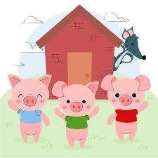

All About Animals

Here is a summary of our planned learning for this half-term. But remember:
No plan in Reception is ‘set in stone’!

Communication, Language and Literacy
Oi Frog – listening to rhymes
The Three Little Pigs – story sequencing
Dear Zoo – speech bubbles
Owl Babies – initial sounds
The Tiger who came to tea – initial sounds

Mathematics
Subitise to 3 – The Three Little Pigs (recognise quantities without counting)
Numbers in the environment
Learning Number rhymes
1 more / 1 less
Patterns – sorting bears (size/colour)

Physical Development
Funky fingers/dough disco/tracing/
Cutting skills – owls
PE Games: Beanbags

Understanding the World
Changes in Season – Autumn/conkers
Use Purple Mash to paint a tiger/owl
Materials – building a house

Expressive Arts and Design
Painting themselves
Tiger Mask
Drawing and painting tigers
Role Play – The Three Little Pigs
House for the Pigs
Clay - animals

Personal, Social and Emotional Development
All About Me – starting school
Class charter: rule and routines

RE
Welcome - We are unique and special
School Values
Introduce ‘Worship Time’ and Cherry of the Day

