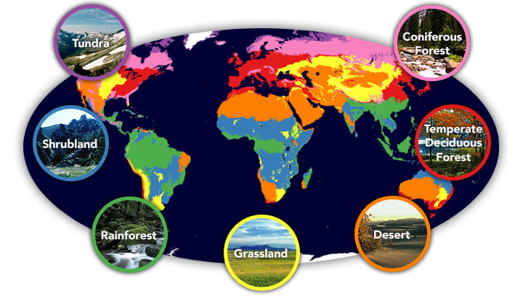
Home, Sweet Biome

In English, we will be…
- Writing narratives including descriptions of a story setting using examples from ‘The Hobbit’, ‘Harry Potter’ and ‘The Explorer’.
- Using the appropriate genre features and showing an awareness of the reader.
  - Using figurative language such similes, onomatopoeia and personification and language that describes the mood and atmosphere of a setting.
  - Using a range of sentence openers and varying sentence structures and to create pace and atmosphere.
  - Using a range of cohesive devices to achieve flow and cohesion.
- Writing persuasive leaflets to reduce plastic waste.
- Writing balanced arguments / discussion texts on themes involving our world and its future.
  - Discussing controversial issues and contributing ‘for and against’ arguments.
  - Evaluating discussion texts and their purpose.
  - Using a range of conjunctions.
- Using organisational and presentation skills to make the most impact on the reader.
- Y4: Using headings and sub-headings to organise ideas.
- Y5: Using the appropriate formal and informal tone according to the genre.
- Developing our skills of self-editing and peer-editing.

In our reading, we will be…
- Identifying features of persuasive texts and balanced arguments.
- Exploring the ways in which grammar, punctuation and vocabulary can be used for effect.
- Using our ‘Reading Roles’ to help us retrieve, infer, define unfamiliar words, deduce and analyse author choices.

In our ‘English Grammar, Punctuation and Spelling’ we will be…

Reviewing our knowledge of all word classes.

Y4: apostrophes for possession, inverted commas for direct speech.

Y5: determiners, pronouns, conjunctions and adverbials.

Reviewing our knowledge of punctuation functions.

Learning the simple and perfect verb tenses.

In Mathematics we will be…
- Place Value: Y4: counting backwards through zero to include negative numbers. Y5: interpreting negative numbers in context, counting forwards and backwards with positive and negative whole numbers, including through zero.
- Geometry: Y4: Comparing and classifying geometric shapes, including quadrilaterals and triangles, based on their properties and sizes. Identifying acute and obtuse angles and comparing and ordering angles up to two right angles by size. Y5: Identifying 3-D shapes including cubes and other cuboids from 2-D representations (nets).
Comparing and classifying shapes based on properties, angles and symmetry. Finding unknown angles in shapes (triangles, quadrilaterals and regular polygons).
- Calculations: Practising mental strategies for all four operations and using problem solving and reasoning to apply our skills in using the written methods for all four operations.
- Fractions: Adding and subtracting fractions. Y4: Adding and subtracting fractions with the same denominator. Recognising and showing, using diagrams, families of common equivalent fractions. Recognising and writing decimal equivalents of any number of tenths or hundredths. Y5: Recognising equivalent fractions, decimals and percentages.
- Problem solving: Y4: Estimating and using inverse operations to check answers to a calculation. Y5: Applying mathematical skills to solve problems and listing all possibilities.

In Science, our topic will be…
- Learning about living things and their environment, identifying organisms and their habitats.

In Design Technology, we will be…
- Designing, making, adapting and evaluating a healthy, environmentally-friendly snack using ingredients from a biome.

In PSHE, we will be…

Discussing the wider world and global issues.

In Geography, we will be…
- Using our location knowledge to identify longitude, latitude, etc. on a world map.
- Describing key aspects of different biomes.
- Studying the physical and human geography of a key region in South America.

In French, our topic will be…

Learning to name and describe animals (Mrs Bartlett).

In Music, we will be…

Learning about musical notation and producing music inspired by animals (Mrs Rennison).

In RE, our topic will be…

Learning about communities and how these are viewed in Islam and Buddhism (Mrs Bartlett).

In PE, our topic will be…
- Playing invasion games with a focus on netball and basketball (Mr Bint).
- Working on shape and balance through gymnastics (Mrs Bartlett).

In Computing, we will be…
- Using logical reasoning to solve problems in simulation programs.
Our key science/geography vocabulary this term will be…
Biomes: biodiversity, boreal forest/Taiga, climate, coniferous forest, continent, climate, deciduous forest, deforestation, desert, ecosystem, environment, equator, flora, forest, global, habitats, humidity, latitude, location, longitude, pollution, rainforest, savanna, season, temperate, temperature, tundra, vegetation belt, weather, etc.

