Cherry Class
Spring Term 1 2025
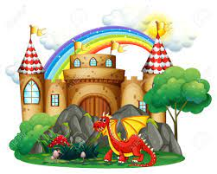
Dragons and Castles

Understanding the World
Welly Walk – the Winter Season focussing on the senses
Nature Area – observational sketching
Chinese New Year
Castle trip
Physical Development
Chinese New Year – dragon dance unit

PSE
Friendships and being kind

Expressive Arts and Design
Paper plate dragons
Chinese New Year dragons
Dragon sock puppets
Clay castle
Chalk castle drawing
Chinese music – responding to a steady beat

Technology
Purple Mash - using computers to paint pictures and add name
Phonics and maths laptop games

Communication, Language and Literacy
Zog – rhyming words and labelling Zog… CVC words
The Egg – reading skills, focussing on predicting events in the story
Tell Me a Dragon – describing dragons
Castle trip recount
Writing a story about their dragon character

Mathematics
Subitising dragons and knights – which is more/less
Number line focus – adding 1 more, taking 1 away
Knights in castles – sharing 5 and 10
Number of the Week 5-10 - different ways to make numbers to 10
3D shapes - naming and properties

RE
The stories Jesus told

