Homework Grid Spring 2: Once Upon a Time
English |  | Maths |  | Topic/Creative
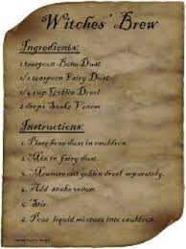  Create your own recipe for a witch’s potion, remember to include ingredients and a method. Can you use alliteration?  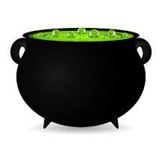 | Date:  Comments: | Continue to practise your current level of mental maths challenge to help you move up to a new level.  Practise the level you are on by repeating it, writing it down and asking your family to help by testing you. Record your practice in your homework book.  Year 1: Can you count onwards and backwards from any given number (up to 20 and beyond)? | Date:  Comments: | Take a walk around your local area, what can you notice that is from the past? For example, old buildings, statues, memorials plaques/signs. Record what you find or draw pictures.  What can it tell you about the history of your local area? | Date:  Comments:
Use your weekly spelling words to write your own fairy tale. Can you include any fairy tale characters or settings?  Once upon a time…..  Long long ago……  In a kingdom far away…. | Date:  Comments: | Geometry  Y1: Find and sort objects into different 2D shapes (square, triangle, rectangle, and pentagon), create a list or pictogram of what you find.  Y2: Find and sort objects into different 2D and 3D shapes, create a list or tally chart of what you find.  Y3: Find objects with angles, decide if each angle is less than a right angle (acute), a right angle or greater than a right angle (obtuse), sort these and create a bar chart or table to record the results. | Date:  Comments: | Create and make a meal or snack inspired by a fairy tale, for example the gingerbread man or an apple cake for snow white.  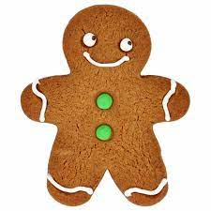  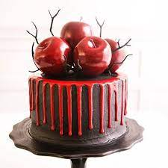 | Date:  Comments:
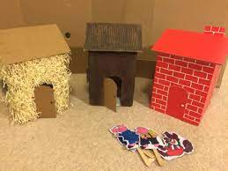  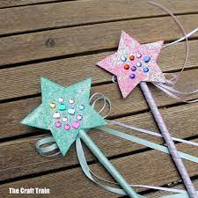  Make your own props and record yourself reading your favourite fairy tale. You can email a video to the office to pass on to your class teachers. | Date:  Comments: | Measure  Using objects around your house, compare and measure the capacity and volume of each.  Y1: Use cubes or other small objects to describe the capacity and volume (full/empty/half full) and record the results (how many cubes to fill?).  Y2: Use ml and l to measure, compare and order the volume and capacity and record results (using <, > and =).  Y3: Use ml and l to estimate, measure, compare and order the volume and capacity and record results (using <, > and =). | Date:  Comments: | 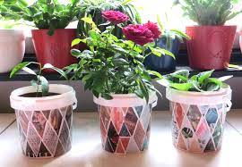  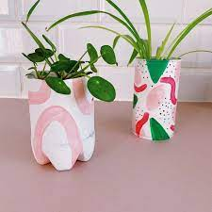  Use junk modelling to create and decorate a plant pot to grow your own plants! For example, you could use old yogurt pots or old bottles, put holes in the bottom and add soil and seeds. | Date:  Comments:
Research a plant, tree or flower and create an acrostic poem about it.  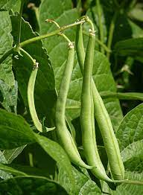  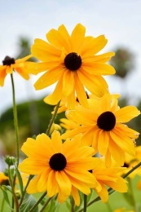  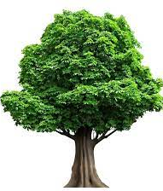 | Date:  Comments: | Statistics  Look in your garden or local area, how many different types of trees or plants can you spot? Record the results and find the most and least common.  Y1: create a pictogram.  Y2: create a tally chart.  Y3: create a bar chart.  Answer questions about the results, for example, find the most common, least common, total trees, total plants. | Date:  Comments: | Draw or use junk modelling to create your favourite fairy tale character or setting.  Y1: Write down which 2D shapes you have used (square, triangle, rectangle, and pentagons).  Y2: Write down which 2D and 3D shapes you have used.  Y3: Write down which 2D and 3D shapes you have used, recognise and describe the different orientations of the 3D shapes used. | Date:  Comments:
Please choose one activity a week, and record which activity has been completed by adding the date into the box provided. Please add comments, should you wish to, regarding your child’s engagement/enjoyment/understanding of each activity. Please choose two from each column during each half term.

