**Who’s In Charge?**

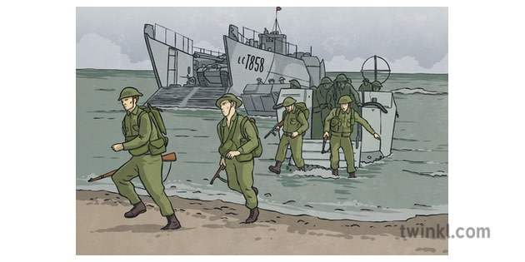

## In English writing, we will be…

* Practicing our writing skills by:
* Writing stories and poems with a historical setting and/or flashbacks.
* Using digital and written texts to drive our writing – *The Piano, The Butterfly Lion and Please Write Soon*.
* ALL – revising our knowledge of a range of punctuation for parenthesis and figurative language for effect,
* Y5 – consolidating our use of relative pronouns and clauses to give detail to the reader.
* Y6 – Revising a range of spelling rules. Reflecting on the use of devices for cohesion in our writing and choosing the most appropriate form.

In English reading, we will be…

* Exploring and analysing a range of non-fiction texts to research the experiences and impact of the Second World War.
* Sharing in group reading of The Butterfly Lion to practise our oracy skills.
* Examining and evaluating the features of historical settings and flashback writing – both in print and digital.
* Using the different ‘Reading Roles’ to help us answer comprehension questions.

In our ‘English Grammar, Punctuation and Spelling’, we will be…

* Reviewing our previous learning including word classes.
* **Y5** revising the use of the hyphen, apostrophe and linking word families.
* **Y6** revising spelling rules.
* Practising **Y5/6** spelling words: interrupt, lightning, opportunity, programme, queue, recognise, restaurant, signature, stomach, suggest, temperature, twelfth, variety, vegetable.

In Mathematics, we will be…

* **Place Value/Calculations:**  addition and subtraction with statistics, four operations with algebra/measurements.
* **Fractions/Geometry:** making links between fractions, decimals and percentage equivalents and geometry.
* **Multiplication and Division:** effective mental methods versus formal written methods.Problem solving for everyday contexts.

In History, we will be…

* Exploring how WW2 came about.
* The everyday experiences of British soldiers and those back home, including evacuation and rationing.
* The roles of men and women – comparing this to modern day conflicts and equality.

## In PSHCE, we will be…

## Taking part in our RSE unit covering changes, positive relationships and reproduction.

## Transition activities in preparation for a new year group or a new school. Reflecting on our achievements this year.

## In French, we will be…

* Discussing a weekend at home. Describing sports.

## In Music, we will be…

## Learning songs in preparation for the KS2 Performance.

## Rehearsing and performing simple songs in an ensemble with accuracy, fluency, control and expression.

## In RE, we will be…

* exploring what kind of King was Jesus and why Jesus is viewed as a King in Christianity.

## In PE, we will be…

* Progressing our skills for a range of athletics activities with a focus on self-challenge and improvement.
* Identifying and discussing strategies within the game of rounders to develop our game as an individual and as a team.

## In Computing, we will be…

* Using our learnt skills for databases and spreadsheets to collate and present data.

## In Science, we will be…

* Continuing our understanding of what electricity is, how it is created and delivered to where it is needed and its many uses in the modern world.

## In Art/Design Technology, we will be…

* Sketching and drawing silhouettes of war.
* Completing a collaborative end-of-year project.

This term’s vocabulary will be…

Conflict, invade, occupy, D-Day, Winston Churchill, Neville Chamberlin, evacuation, billeting officer, munitions.