Willow Homework Grid: Down Mexico Way
I I did this independently with no help.
S I did this with some support.
H I needed lots of help and found it tricky.

English |  | Maths |  | Topic/Creative
Writing:  Create your own Mayan God or Goddess. Start by drawing and labelling them then use this to write a C.V. for them. What are their skills and qualities? What are their hobbies and interests? How have they gained the knowledge/status they have? What roles do they succeed best in? Be as creative as you can!  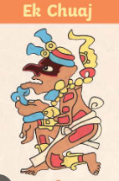 | Date:  Comments: | Metric Units:  Y5/6: 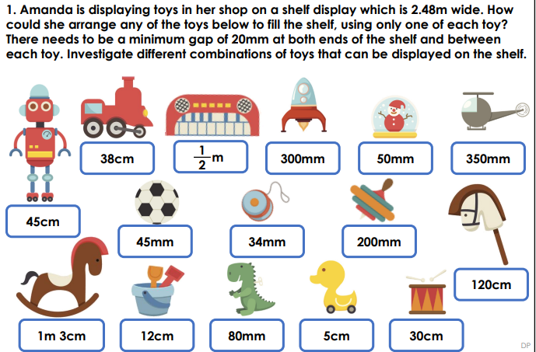 | Date:  Comments: | History:  Create your own Mayan timeline in the form of a storyboard or comic. Ensure you show the important dates, events and achievements of this civilisation.  Computing:  Design and make a game linked to Mayan Gods and Goddesses, or any idea of your own, related to the Mayan civilization. | Date:  Comments:
 |  |  |  | Science:  Choose one or two of the following and create your own facts sheets explaining the effects they have on the body and how they help it to run effectively and stay healthy: protein, carbohydrates, fats (some are more useful than others!), vitamins and minerals, fibre, calcium, etc. | Date:  Comments :
Writing:  Using the knowledge you have from your reading in school, write your own Mayan myth. You could use the hero twin characters featured in many Mayan myths: Hunahpu and Xbalanque or the Mayan God or Goddess you have created above. | Date:  Comments: | Imperial Units:  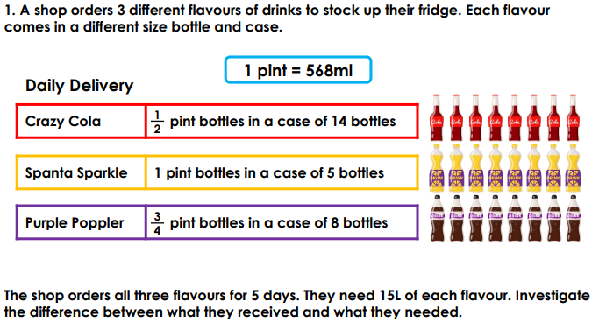 | Date:  Comments:
 |  |  |  | Art and Design:  Recreate the Mexican flag in a creative  way, e.g. drawing, finger painting, collage, food presentation, textiles, digital art.  DT  Make a typical Mexican dish such as guacamole, tacos or fajitas. Bring in pictures and instructions/the recipe. | Date:  Comments:
Reading:  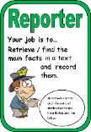  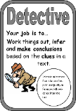  Based on the Mayan myth you have written, construct questions for a friend or family members to answer. Base them around our Reading Detective Roles and make sure you can answer them yourself so you can mark them! | Date:  Comments:
 |  |  |  | PSCHE / Family Discussion activity:  Complete this at the end of this term. Share what you have learnt about the Mayans with your family and discuss what problems did the Mayans face that could explain their decline? How do you think they would view our world today? If they were still here, what different challenges would they face? | Date:  Comments:
 |  | Shape: there are Purple Mash tasks set as a 2Do. | Date:  Comments:
Spelling Practice: include your focus words in compound and complex sentences using the appropriate conjunctions.  Y5 - Y5/Y6 words (communicate to curiosity). Y6 - Use 15 of the Y5/Y6 words (controversy to equipped).  communicate, community, competition, conscience, conscious, controversy, convenience, correspond, criticise, curiosity, definite, desperate, determined, develop, dictionary, disastrous, embarrass, environment, equip, equipped | Date:  Comments:
 |  | Multiplication – use a formal written method  347 x 29 = 18 x 295 =  456 x 14 = 61 x 79 =  1,084 x 12 = 0.46 x 231 = | Date:  Comments:

