Cherry Class
Autumn Term 2 2024
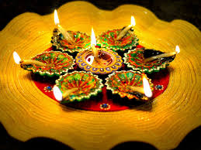
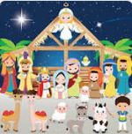
Celebrations
Communication, Language and Literacy
Gingerbread Man - CVC writing and reading
Fireworks words – initial sounds
The Diwali Story of Sita and Rama – retell the story, initial sound writing
Birthday cards/shopping lists for a birthday party
Re-tell Nativity story, write about role

Mathematics
Fireworks take away
Gingerbread Man numbers –recognising numbers/number bonds to 5
Candles on a cake – sharing 5
Number of the week 5-10
Length – Christmas tree branches and comparing tinsel and paperchains
2D/3D shapes – Christmas themed

Technology
Introduce logging in to Purple Mash and printing
Using computers to paint pictures and add name e.g. fireworks

Physical Development
Balances for good co-ordination and travelling in gym

PSE
The Colour Monster – exploring emotions and feelings

Understanding the World
Welly Walk – change of seasons
Fireworks and Diwali
Remembrance
Nativity Story

Expressive Arts and Design
Fireworks pictures
Diwali Art,
Clay Diva
Remembrance Day art
Christmas cards and decorations

RE
Celebrating Birthdays, Gilbert turns 5, the birth of Jesus
Nativity Story

