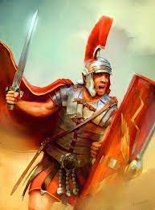
Willow Homework Grid: ‘What Did the Romans Ever Do For Us?’
I I did this independently with no help.
S I did this with some support.
H I needed lots of help and found it tricky.

English |  | Maths |  | Topic/Creative
Reading:  Read 2 myths, legends or folk tales from other cultures. Write a review of them– remember to include the age range that it they would suit best, a brief summary of the characters, setting and plot. Can you then compare them – what is similar, what is different? Consider the plot but also how the author has used vocabulary, figurative language, speech (Y6 – levels of formality) and action to help develop the plot..  You can find some examples here: http://www.history-for-kids.com/myths-and-legends.html  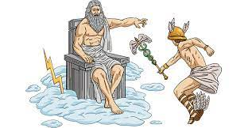 | Date:  Comments: | Factors and Multiples:  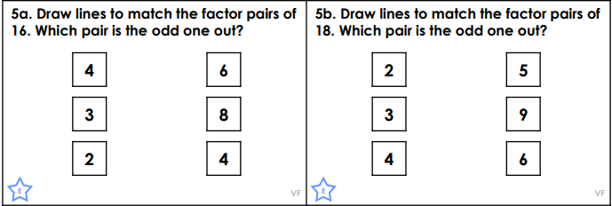  Y5/6:  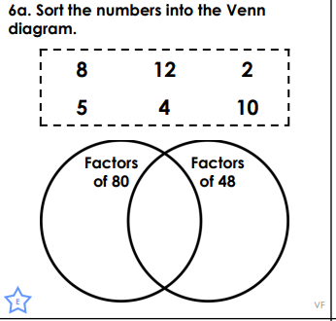  Y6  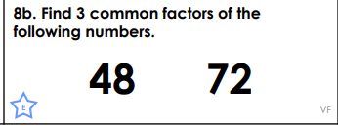 | Date:  Comments: | History:  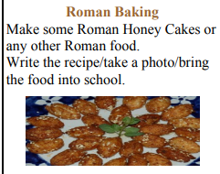  Can you rewrite the recipe using Roman Numerals for the quantities of ingredients? | Date:  Comments:
 |  |  |  | Science:  Research the digestive system of an animal of your choosing, then draw labelled diagrams to compare it to that of a human. Ensure you include the relevant scientific vocabulary and clearly explain their similarities and differences.  Y6: Can you explain how the digestive system of your animal suits its diet and habitat? | Date:  Comments :
Writing:  Using one of the stories from your reading activity – rewrite it but make changes. You could redesign the character, setting or plot. You could change them all! Use an S-map to plan your new story with annotations for vocabulary, direct speech (Y6 – dialogue to convey personality/behaviour) and changes in setting/action. Create drawings/comic strip to help develop the descriptive language for your character. | Date:  Comments: | 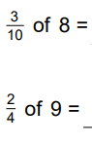  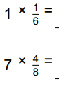  Fractions:  Y5/6  Y6  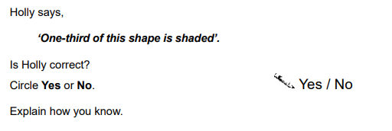 | Date:  Comments:
 |  |  |  | Art and Design:  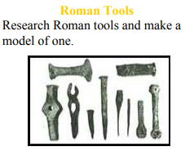 | Date:  Comments:
Writing:  Create a detailed and informative advertisement, encouraging a young person to join the Roman Army and expand the Roman Empire. What are the benefits? Travel, status and glory, defending your people etc. How will you turn the negatives into positives? | Date:  Comments:
 |  |  |  | PSCHE / Family Discussion activity:  As a family discuss things that you do to physically stay healthy – do you do a range of activities that help strengthen and work different parts of your body or do you each have one preferred activity? Does your diet support a healthy lifestyle and helps your digestive system work to its best ability? What does it feel like when you don’t eat healthily and/or get enough exercise? | Date:  Comments:
 |  | Calculations: there are Purple Mash tasks set as a 2Do. | Date:  Comments:
Spelling Practice:  Y5 - Make your own dictionary entries, using 10 of the Y5/Y6 words (appreciate to committee). Y6 - Use 15 of the Y5/Y6 words (appreciate to conscious). Appreciate, attached, available, average, awkward, bargain, bruise, category, cemetery, committee, communicate, community, competition, conscience, conscious  For a challenge, create thesaurus entries with synonyms. | Date:  Comments:
 |  | 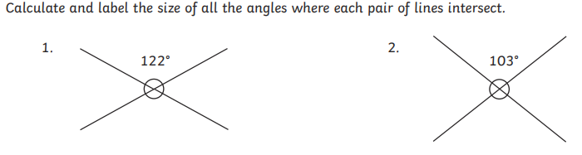  Geometry – EXPLAIN HOW YOU KNOW USING A LABELLED DIAGRAM AND MATHEMATICAL VOCABULARY! | Date:  Comments:

