Cherry Class
Autumn Term 2 2022
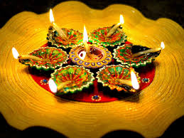
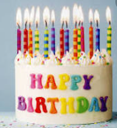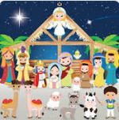
Celebrations

Communication, Language and Literacy
Sam’s Sandwich – yuk sandwiches
Gingerbread Man - CVC writing and reading
Fireworks words e.g. pop
The Diwali Story of Sita and Rama – retell the story, initial sound writing
Birthday cards/shopping lists for Birthday Party
Re-tell Nativity story, write about role

Mathematics
Subitising Sam’s Sandwich bugs on a 5 frame
Fireworks take away
Gingerbread Man numbers –recognising numbers/number bonds to 5
Candles on a cake – sharing 5
Number of the week 5-10
Length – Christmas tree branches and comparing tinsel and paperchains
2D/3D shapes Christmas themed

Technology
Introduce logging in to Purple Mash and printing
Using computers to paint pictures and add name

Physical Development
Balances for good co-ordination and travelling in gym

Understanding the World
Welly Walk – change of seasons
Fireworks and Diwali
Remembrance
Nativity Story

Expressive Arts and Design
Fireworks pictures and Diwali Art, clay Diva
Oil pastel pumpkins
Remembrance Day art
Christmas cards and decorations

PSE
The Colour Monster – exploring emotions

RE
Celebrating Birthdays, Gilbert turns 5, the birth of Jesus
Nativity Story

