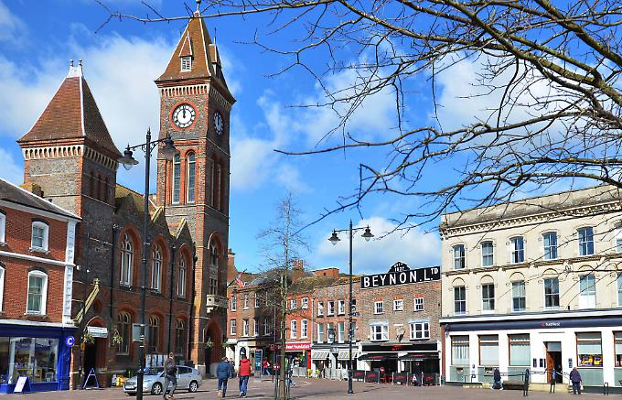
Our World!
Sycamore Class
Summer 2 2026
English
Writing
- Focus text and other themed texts around ‘Our World!’
- Key skills – focussing on using a range of sentence types, as well as conjunctions (and, because, when, if, so, but), using language for impact - including the use of expanded noun phrases, and editing our work.
- Handwriting – continuing to focus on joined hand-writing, thinking about the size of our writing and the relationship between the lower-case and upper-case letters.
- Phonics – building on existing phonics knowledge and introducing alternative sounds.
- Spelling – continuing our yearly spelling programme – working on key word patterns each week in conjunction with the common exception words for each specific year group (spellings will come home associated with this programme weekly).

Reading
- Whole class reading activities linked to our focus texts and other similar texts.
- Continuing to use our phonic skills to decode new words, and use word patterns to help us (linked to spelling).
- Focusing on our understanding of character motivation using our inference skills, the author’s use of language for effect and making predictions after reading the text.
- Recognising different themes and convention of texts.
Mathematics
- Place value – partition 2-digit numbers in different ways, practice our counting patterns (2s, 3s, 5s, 10s), notice and describe patterns showing an increasing understanding of the properties of numbers.
- Addition and Subtraction – recall and use addition and subtraction facts up to 20 fluently, derive and use related facts up to 100, add and subtract both 1-digit and 2-digit numbers, solve missing number problems, know a variety of mental strategies, including bridging and choose which is most efficient.
- Multiplication and division – quick fire recall of multiplication tables (2s, 5s, 10s), write down related multiplication and division facts.
- Fractions – understand fractions are equal parts of a whole, finding fractions of length, shapes and quantities, counting in fractional steps, making links to multiplication and division when solving problems.
- Problem Solving – solve 2-step problems in a range of contexts, including those involving change up to £1.
- Measures – estimate, measure and compare length, mass and capacity/volume.
- Geometry – use appropriate vocabulary to identify and describe the properties of 2D shapes, 3D shapes, positions, directions and movements.

Science
- Plants need the right amount of light and water, as well as a suitable temperature, to grow and stay healthy.

Geography
- Investigating maps and pictures.
- Locating and identifying features on a map, creating our own.
- Use compass points to navigate a map.
- Use simple fieldwork & observational skills to study the surrounding environment in the context of children’s own locality.

R.E – Creation
- Finding out what the creation story tells us about God and human beings.
- Describing examples of what Christians do to care for the world.

P.E.
Athletics/ Rounders
- Understand and identify good striking and fielding techniques.
- Combine skills to play effectively in a small sides striking/fielding game and use simple attacking and defending tactics e.g. work as a team to field the ball.

PSHCE
- Understand who can help us stay safe in familiar and unfamiliar environments.
- Discuss different situations, including those online and emergencies and how to ask for help.
- Reflect on the academic year and talk about next year.

Art
- Explore sketching techniques with pencils and pens.
- Design an Andy Goldsworthy inspired artwork.

Music
- Learn to play a few more notes on the recorder.
- Rehearse and perform with the class.

Computing
- In Purple Mash 2Code, use object, action and event code blocks to make a computer program.
- Run programs, identify errors and fix them.
- Create a sequence of instructions to move a BeeBot to move to a specific location on a map.

Topic Words
Geography – local, world, Newbury, Berkshire, Hampshire, wonders, country, urban, landscape, habitat, environment

