
Willow Homework Grid: What’s That Noise?
I I did this independently with no help.
S I did this with some support.
H I needed lots of help and found it tricky.

English |  | Maths |  | Topic/Creative
Writing: Letter  As we are coming to the end of the school year, write a letter to the ‘you’ who started back in September.  Tell the September you all the great things you have achieved and what was difficult along the way. How did you overcome these obstacles? What have you learnt about yourself and what are you looking forward to next? How have your friends and adults helped you? Who have you helped? Which of our values and learning skills can you prove you used?  Things to remember:  - First person  - Past tense  - Emotive vocabulary  - Quotes and internal thoughts  - Rhetorical questions  - Thoughts for the future | Date:  Comments: | 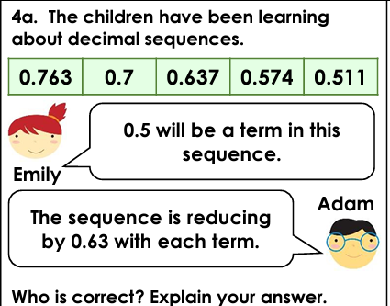  Linear sequences:   | Date:  Comments: | 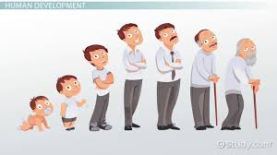  Science – create a timeline of the development of yourself or someone in your family. Annotate it with specific dates and events, drawings/photographs and the changes you notice in appearance, ability, interests and behaviour - how is the 1 year old you different to the modern day you? | Date:  Comments:
 |  |  |  | Art and Design:  As our topic this term is linked to noise – collect up some art/construction materials; choose your favourite piece of music to play, close your eyes for a few moments and listen. Then create what the music makes you feel and imagine. What you produce and how you go about expressing yourself is entirely up t you!      This link has information about famous art inspired by music: https://www.arthistorykids.com/blog/247 | Date:  Comments :
Writing: Biography  Interview a friend of family member and then write a biography about them. Include their early life, family, school, career, achievements and what makes them unique! Write in the 3rd person and use their exact quotes to give evidence of their feelings and experiences. You could even include drawings/photographs. | Date:  Comments: | Multiplication and Division:  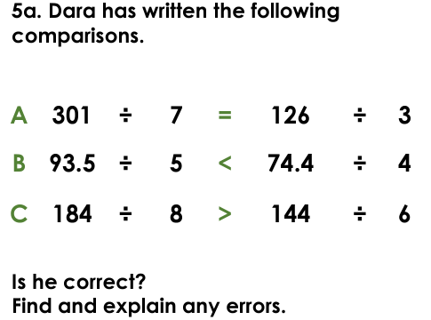  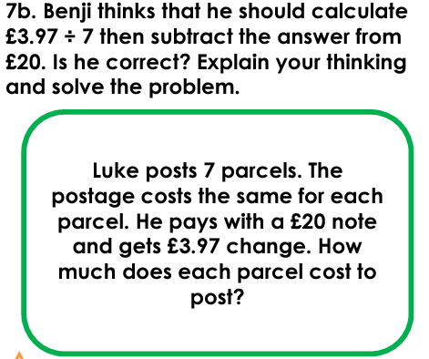  Fractions/Measurement – Purple Mash tasks. | Date:  Comments:
Date:

Comments:

Reading:  Choose a book you wouldn’t normally read and challenge yourself to give it a go!  Find:  - 2 pieces of text/facts you really liked.  - 3 pieces of vocabulary you haven’t heard/used before.  - A sentence opener you intend to use in your own writing.  Write a review of the book – summarise whether you would recommend it or not and WHY! | Date:  Comments:
 |  |  |  | PSCHE / Family Discussion activity:  How do different people manage friendships and do all frienships look the same?  Do people in your family ever have challenges within their friendships and how do they go about resolving them?  What are the benefits of frienships where everyone feels values and listened to? Why are friendships important as we go through life? | Date:  Comments:
Date:

Comments:
Spelling Practice: include your focus words in sentences linked to our Science topic.  Y5 - Y5/Y6 words exaggerate, excellent, existence, explanation, familiar, foreign, forty, frequently  Y6 - Y5/Y6 words interfere, interrupt, language, leisure, lightning, marvellous, mischievous, muscle, necessary, neighbour | Date:  Comments:
Date:

Comments:

