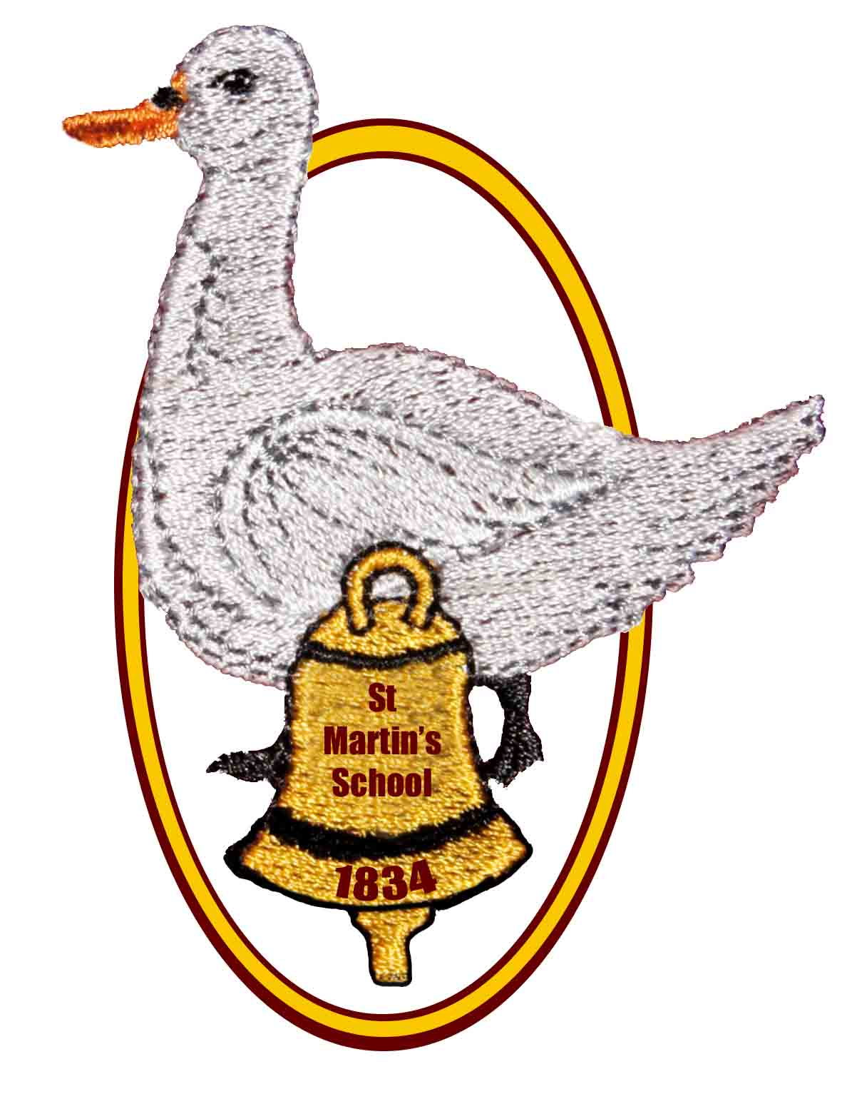

St Martin’s School

Headteacher: Mrs K. Bartlett Chair of Governors: Mrs L Chorley

OPEN MORNING, AFTERNOON AND EVENING

for parents of children who are due to start school in September 2023

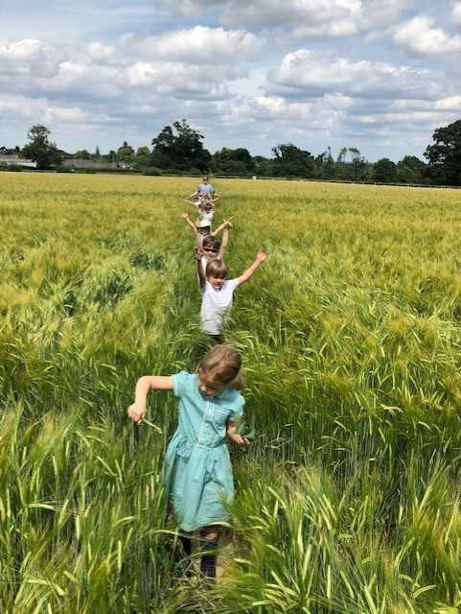We would like to invite you to find out more about

## St Martin’s

## Church of England (Aided)

## Primary School

**East End, Newbury, RG20 0AF**

**on**

**Monday 7th November**

**9.30am, 1:30pm or 6.00pm**

**We are planning to start each session with a short presentation by the Headteacher and Deputy Headteacher, followed by a tour of the school led by our school ambassadors and an opportunity to look round the school grounds. If you would like to attend, please phone the school and book in to a session. We look forward to meeting you!**

**In the meantime, please explore our school website to find out more about us – there is a special page for prospective parents, which includes the presentation from our previous open events and a video tour of our Year R classroom.**



**If you have any questions or would just like a chat with the Headteacher about our wonderful school,**

**please contact us on 01635 597796**

**or e-mail**

[**adminoffice@st-martins.hants.sch.uk**](mailto:adminoffice@st-martins.hants.sch.uk)

**Come and see our new Year R outdoor area, which was installed in October 2021!**