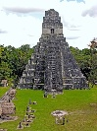
Willow Homework Grid: The Maya!
I I did this independently with no help.
S I did this with some support.
H I needed lots of help and found it tricky.

English |  | Maths |  | Topic/Creative
Writing:  Create your own Mayan God or Goddess. Start by drawing and labelling them then use this to write a C.V. for them. What are their skills and qualities? What are their hobbies and interests? How have they gained the knowledge/status they have? What roles do they succeed best in? Be as creative as you can!  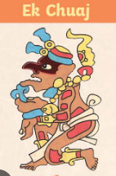 | Date:  Comments: | Metric Units:  Y5/6: 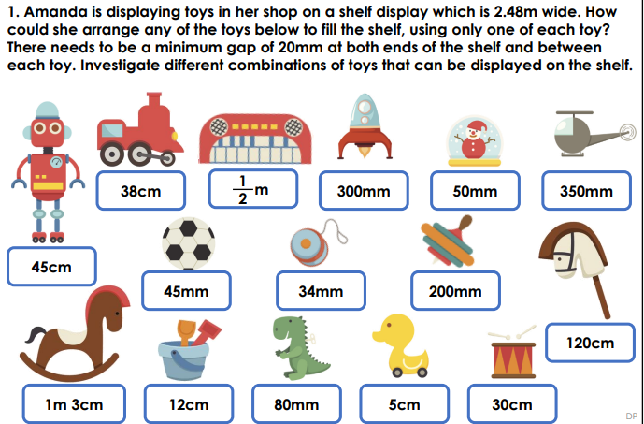 | Date:  Comments: | History:  Create your own Mayan timeline in the form of a storyboard or comic. Ensure you show the important dates, events and achievements of this civilisation.  Computing:  Design and make a game linked to Mayan Gods and Goddesses, or any idea of your own, related to the Mayan civilization. | Date:  Comments:
 |  |  |  | Science: Evolutionary Inventor Challenge: Become a De-Evolution Detective by choosing any modern animal and sketching what its ancient fossil ancestor might have looked like millions of years ago! Label three specific adaptations that helped it survive in its prehistoric habitat. Then, create a simple classification key using "Yes" or "No" questions (e.g., Does it have fur? Does it walk on four legs?) to help a scientist group and identify your creature. 🦖 | Date:  Comments:
Writing:  Using the knowledge you have from your reading in school, write your own Mayan myth. You could use the hero twin characters featured in many Mayan myths: Hunahpu and Xbalanque or the Mayan God or Goddess you have created above. | Date:  Comments: | Imperial Units:  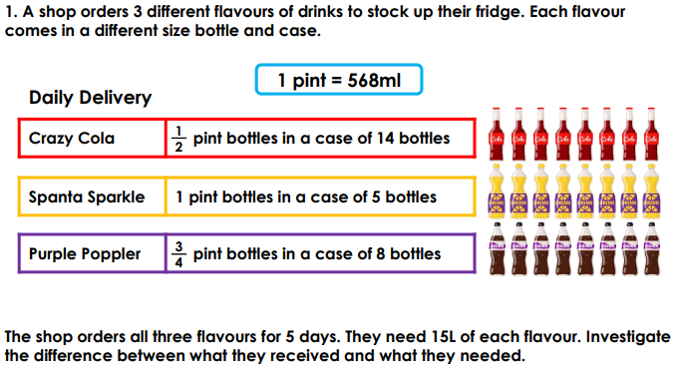 | Date:  Comments:
 |  |  |  | Art and Design:  Recreate the Mexican flag in a creative  way, e.g. drawing, finger painting, collage, food presentation, textiles. Digital art  DT  Make a typical Mexican dish such as guacamole, tacos or fajitas. Bring in pictures and instructions/the recipe. | Date:  Comments:
Reading:  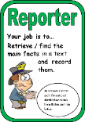  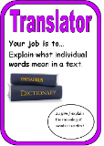  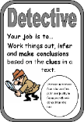  Based on the Mayan myth you have written, construct questions for a friend or family members to answer. Base them around our Reading Detective Roles and make sure you can answer them yourself so you can mark them! | Date:  Comments:
 |  |  |  | PSCHE / Family Discussion activity:  Everyday Safety Secret Agent Mission: Become a Safety Secret Agent by completing a home safety sweep with an adult! Walk through your house to spot and fix hazards like trailing wires, blocked stairs, or inward-facing pan handles. Next, draw a quick Emergency Action Map showing your home's exit routes, an outdoor meeting spot, and emergency numbers. Finally, agree on three golden rules with your family for staying safe online, and have an adult sign off your mission to award you your Safety Special Agent Badge! 🕵️‍♂️ | Date:  Comments:
 | Date:  Comments: | Shape: there will be Purple Mash tasks set as a 2Do . | Date:  Comments:
Spelling Practice: include your focus words in compound and complex sentences using the appropriate conjunctions.  Y5 - Y5/Y6 words (communicate to curiosity). Y6 - Use 15 of the Y5/Y6 words (controversy to equipped).  communicate, community, competition, conscience, conscious, controversy, convenience, correspond, criticise, curiosity, definite, desperate, determined, develop, dictionary, disastrous, embarrass, environment, equip, equipped | Date:  Comments:
 | Date:  Comments: | Multiplication – use a formal written method  347 x 29 = 18 x 295 =  456 x 14 = 61 x 79 =  1,084 x 12 = 0.46 x 231 = | Date:  Comments:

