English |  | Maths |  | Topic/Creative
  Imagine you are Paddington writing a postcard to Aunt Lucy and Uncle Pastuzo in Peru. Write about your experience arriving in London.  Remember to use the conjunctions: but, and, because. | Date:  Comments: |   Practise counting up to 100, forwards and backwards.  Start counting from different 2-digit numbers, write these into your homework book. If you want a challenge, count up to and back from 120. | Date:  Comments: |   Design a new outfit for Paddington to wear whilst on an adventure holiday (e.g. skiing, surfing, rock climbing).  Label the materials you would use and reasons why. | Date:  Comments:
  With an adult, use the internet to research the Paddington author Michael Bond and make a fact file.  Include where he was born, where he lived and when he began writing the Paddington books. | Date:  Comments: | Practise counting in steps of 2s, 3s and 5s from 0 and count in steps of 10s from any number, forwards and backwards.  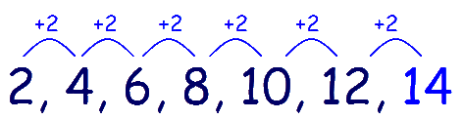 | Date:  Comments: |   Create a map of Peru.    Include compass directions (N, E, S, W)  Identify some key landmarks. | Date:  Comments:
  Write a story including your favourite teddy as the main character.  Use adjectives to make your writing more interesting. | Date:  Comments: | 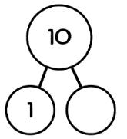  Practise number bonds to 20.  Can you write in your homework book in a part-whole model? | Date:  Comments: | 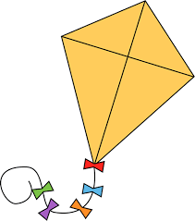  Make a kite using different materials.  Discuss the suitability of the materials chosen. | Date:  Comments:
Make a recipe including ingredients and numbered steps of how you would make your favourite sandwich.    You could even make it after following your own recipe! | Date:  Comments: | Star numbers  Choose a 2-digit number and write it in your homework book. Now see how many calculations you can think of to get that number as your answer. For example, with the number 12, you could have 10 + 2, 20 – 8, 6 + 6, etc.  You could repeat with different numbers too! | Date:  Comments: |   Create a travel agent poster to persuade someone to go to Peru, including some information, activities to do there and of course some pictures. | Date:  Comments:
Homework Grid Autumn 1
Please choose one activity a week, and record which activity has been completed by adding the date into the box provided. Please add comments, should you wish to, regarding your child’s engagement/enjoyment/understanding of each activity. Please choose at least two from each column during each half term.

