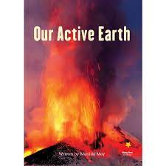
Maple Homework Grid: ‘Active Earth’
I I did this independently with no help.
S I did this with some support.
H I needed lots of help and found it tricky.

English |  | Maths |  | Topic/Creative
Reading:  Read and analyse two different information texts. Then complete the features table.  Yes No  Topic Title?  Paragraphs organised around a theme?  Present tense?  Third person pronouns?  Pictures/diagrams?  Glossary? | Date:  Comments: | Place Value:  Complete the sequences counting back and forwards in 10s:  Y4 a) 345, ____, ____, ____, ____, 315, ____, ____.  Y4 b) ____,____, ____, 217, 227, ____, ____, 257.  Y5 c) 345,000 _______, ______, 315,000, _______.  Y5 d) ______, 122,903, 112,903, ________, _______.  Can you solve the following word problems?  - A supermarket sells 143, 687 litres of milk in one month. How many L is this to the nearest 10,000 and 100,000?  - 529,876 adults and 225,621 children visit a zoo in 1 year. How many people visit the zoo in one year to the nearest 10,000 and 100,000? | Date:  Comments: | Geography:  Research the locations of volcanoes across the world. Can you mark them accurately on a map? What do you notice about their placement? Why do you think this is? Y5 - Use your knowledge of biomes to help you identify and label the different types of landscapes.  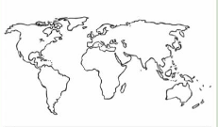 | Date:  Comments:
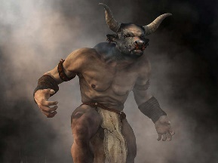  Writing:  Research the history of a volcano. Draw it (it can be an image of it erupting.) Write a range of descriptive vocabulary using expanded noun phrases, similes, etc. Think about its appearance, its features, the impact it has on the landscape around it and its actions.  Y5: Include metaphors and personifications. | Date:  Comments: | 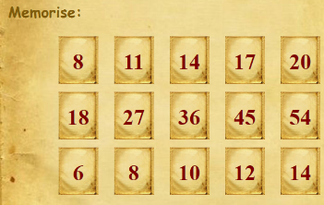  Memory Maths:  Have someone at home ask you the following questions:  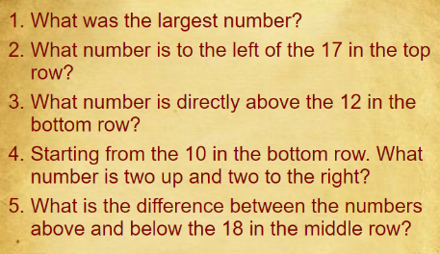 | Date:  Comments: | 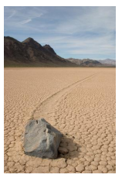  Science: Sliding rocks of racetrack playa – Find out what these rocks can do in a place called ’Death Valley’. Include detail of the different explanations of how these rocks mysteriously move across the vast dry lake bed. | Date:  Comments:
Writing:  Create a detailed and informative safety poster for those living close to a volcano or other force of nature. Think about how to recognise danger signs, safety-proofing your home, survival supplies and what to do/what not to do in an emergency etc. | Date:  Comments: |  |  | Art and Design:  Design your own volcano sculpture – you can chose any media but it must be 3D: recycled packaging, organic materials, Lego, play-doh etc. Be as creative as you can! | Date:  Comments:
 |  | Fractions: there are Purple Mash tasks set as a 2Do.  PLEASE COMPLETE AFTER WEEK 5! | Date:  Comments: | PSCHE / Family Discussion activity:  As a family discuss things that you do to work together as a team. What rights does each of you have in your home and how do you work together to be respectful of other’s rights? Why might this be different for children in other countries? | Date:  Comments:
Spelling Practice:  Y4 – Write 5 sentences including two of the following common exception words in each sentence: accident, actually, address, although, answer, appear, arrive, believe, bicycle, breath.  Y5 - Make your own spellings crossword or a word search using 8 of the following word: Accommodate, accompany, according, achieve, aggressive, amateur, ancient, apparent. | Date:  Comments:
 |  | Geometry: 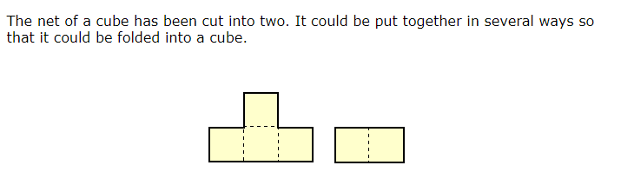How many possibilities are there? Can you prove your answer? Draw each possible net onto card/paper and then construct each net? | Date:  Comments:

