Willow Homework Grid: Space Explorers
English |  | Maths |  | Topic/Creative
Writing:  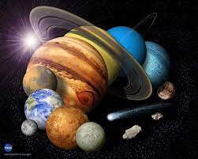  Is there life on other planets? Write a balanced argument debating the reasons for and against this topic. Consider what you know about the planets in our solar system and what is needed for living organisms to exist. How would they survive and how would they need to be different to use? | Date:  Comments: | Place Value:  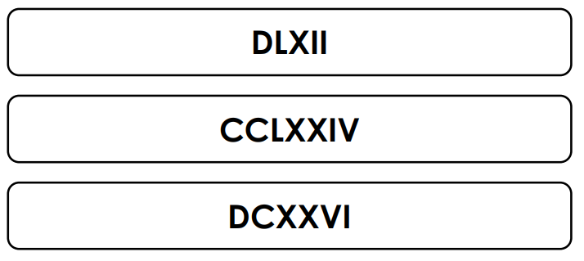  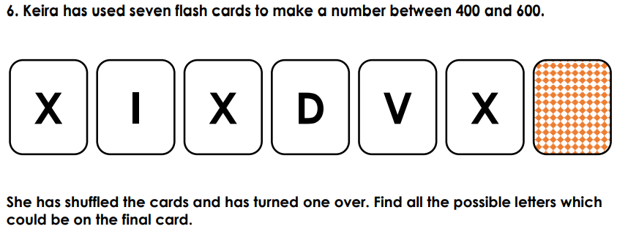 | Date:  Comments: | History: can you research significant space explorers in modern history and create your own timeline? Include the dates of their achievements, what they did and why it was a step forward in our understanding of our universe?  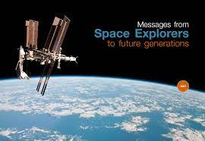 | Date:  Comments:
 |  |  |  | Science/Computing – complete after Week 3:  Can you create a stop-motion animation of our solar system? Think about the order of the planets, the distance between them and their journey around the sun. Add narration to explain the features of the different planets and the distances between them. | Date:  Comments :
Writing:  Either, take an existing piece of space exploration equipment that you have researched, or, invent your own. Can you write an explanation text, or, a persuasive speech to persuade a company to manufacture it? Include labelled diagrams so they can see exactly what it looks like/how it works/its benefits. | Date:  Comments: | Time: use a timeline to help you.  Calculate the time intervals between:  - 12:00 – 14:25 8) 12:12 – 16:42  - 16:50 – 19:15 9) 17:59 – 18:11  - 17:45 – 21:30 10) 01:17 – 19:10  - 11:20 – 15:40 11) 09:41 – 16:02  - 12:15 – 20:10 12) 10:26 – 14:09  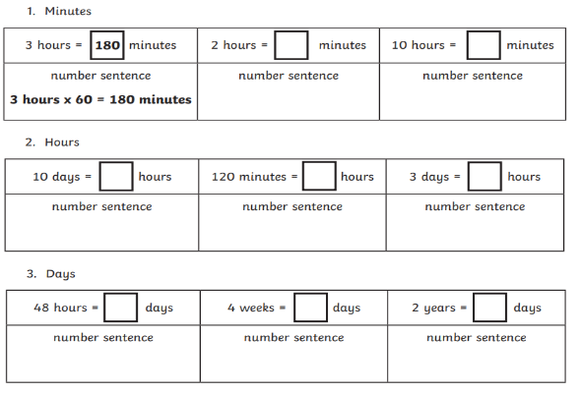 | Date:  Comments:
 |  |  |  | Art and Design:  Practise your pencil skills – choose a landscape/view to observe. Sketch, shade, blend and add texture to create your piece. Can you show the same landscape at different times of day and how the light is different?  DT  Create a model of the piece of equipment you invented/improved in your writing task. | Date:  Comments:
Reading: complete after week 5  Based on our reading of Cosmic, write a summary of the story.  What are the main settings, characters and events? What are the main plot points?  Convey this information in an  engaging yet succinct manner  to draw in your reader. | Date:  Comments:
 |  |  |  | PSCHE / Family Discussion activity:  Why is it important to the human race to explore space?  What are your thoughts on the amount of ‘space debris’ that we have left in space?  Should we be using our resources to travel further in to space and what impact might we have on our solar system?  What do you think our space exploration will be like in 10, 20, 50 and a 100 years? | Date:  Comments:
 |  | 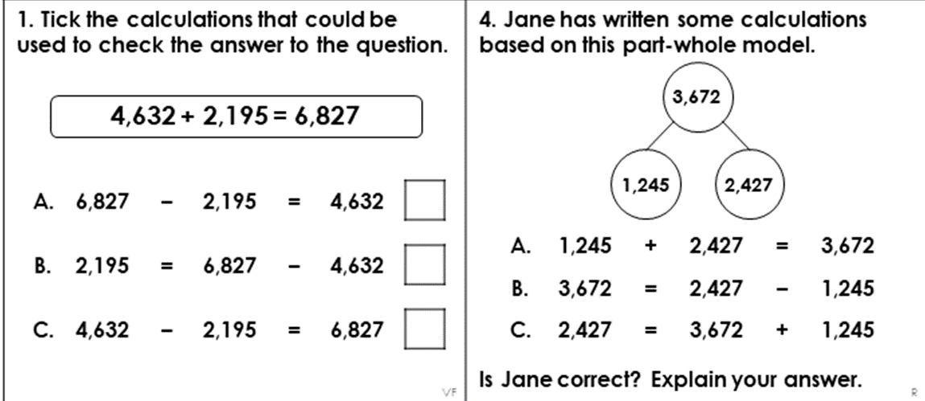  Missing number problems/inverse operations:  Geometry: there are Purple Mash tasks set as a 2Do. | Date:  Comments:
Spelling Practice: include your focus words in sentences which use the active/passive voice.  Y5 - Y5/Y6 words (definite to disastrous).  definite, desperate, determined, develop, dictionary, disastrous  Y6 - Y5/Y6 words (especially to frequently).  especially, exaggerate, excellent, existence, explanation, familiar, foreign, forty, frequently | Date:  Comments:
Date:

Comments:
I I did this independently with no help.
S I did this with some support.
H I needed lots of help and found it tricky.

