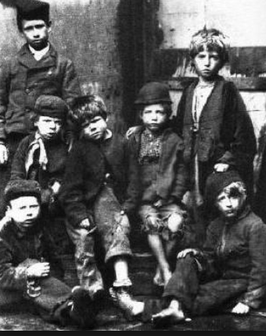

**The Victorians**

Key Stage One

Spring 1 2025

**English**

**Writing**

* Y1: focusing on using capital letters and full stops to demarcate sentences, and beginning to use question marks and exclamation marks.
* Y2: focusing on writing commands and exclamatory sentences, past and present tense and a range of conjunctions.
* Handwriting – focussing on developing our joined script, with well-sized finger spaces.
* Non-fiction – instruction writing, using imperative verbs, thinking about the kind of language needed to write clearly and concisely.
* Fiction – writing simple, coherent narratives, using a range of descriptive language.
* Spelling/phonics - following the Twinkl phonics programme.

**Reading**

* Whole class reading activities linked to our focus texts and other similar texts, focussing on our understanding of character motivation using our inference skills and the author’s use of language to enhance our understanding.
* Y1: continue to work on decoding skills and developing our comprehension skills.
* Y2: answering questions, making predictions and making inferences about the texts we read.

**Mathematics**

* Number

Y1: Embedding our understanding of numbers to 20.

Y2: 2-digit numbers, and practicing our counting patterns (2s, 5s, 10s).

* Addition and subtraction

Y1: confidence in adding and subtracting 1-digit numbers. Y2: 3, adding and subtracting 1-digit numbers, 1-digit numbers and tens to/from 2-digit numbers.

* Solving problems

Y1: Solving 1 step problems.

Y2: Solving 2 step problems in a range of contexts.

* Multiplication and division

Y1: grouping, doubling and sharing.

Y2: representing multiplication facts for 2s, 5s, 10s times tables, solving multiplication and division problems in context.

* Fractions – finding fractions of shapes.
* Measures

Y1: using standard units to measure mass.

Y2: estimating, measuring and comparing mass.

* Time

Y1: telling the time and drawing the time on clock faces, o-clock and half past.

Y2: telling the time and drawing the time on clock faces, o-clock, half past, quarter past and quarter to.

* Geometry

Y1: recognising and describing 2D shapes using their properties.

Y2: identifying and describing the properties of 2D and 3D shapes.

* Statistics

Y2: Interpreting and constructing simple pictograms and tally charts and asking and answering simple questions.

**Science**

* Identify things that are living, things that are dead and things that have never been alive.
* Animals are groups of organisms that need to consume food to survive.
* Food provides energy and the building blocks of growth.
* Animals must move to get their food.
* Animals will move in different ways to get their food.
* Animals that eat other animals are called predators.
* Animals that are eaten by other animals are called prey.
* Animals feeding relationships can be illustrated in a food chain.

**History**

* Understanding how artefacts, pictures and other resources help us to learn about the past.
* Learning about Queen Victoria and the key changes she made during her reign.
* Comparing our lives now to those of children in Victorian times, learning about Victorian lives, homes, schools (including punishments) and jobs.
* Experiencing a Victorian School Day and compare this to our school today.

**Art and Design**

* Learning about the life of LS Lowry and making a Lowry city collage learning about perspective and using collage.

**R.E – Friendship**

* Discovering the good news that Jesus brings to Matthew and Zacchaeus.
* Considering what makes a good friend.

**Music**

* Learning, composing and performing Victorian street cries.

**P.E.**

* Victorian Drill and other Victorian playground games.
* Net Games – tennis and badminton.

**Computing**

* Internet research
* Learning key skills to write a document and insert pictures

**PSHE**

* Thinking about our family.
* Understanding we belong to different groups and communities.
* Understanding the responsibilities we have towards the groups and communities we belong to.
* Understand what it means to be British.

**Role Play Corner**

* A Victorian School!

**Key Vocabulary**

* Victorians, queen, royalty, monarch, poverty, wealth, drill, orphans, work house, disease, nutrition, school, groups, communities.