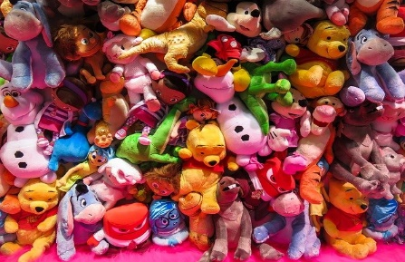Toys!

Sycamore & Silver Birch Classes

Autumn 2 2023

**English**

* **Writing**
* Toy-themed texts
* Key skills – (Y1) composing and recording sentences, thinking about capital letters, full stops and finger spaces, (Y2) focusing on using a range of sentence types, as well as conjunctions (and, because, when, if, so, but), (Y3) continuing to embed our understanding of the difference between simple and compound sentences as well as a range of conjunctions (although, while, since, until), introduction of fronted adverbials in our writing, understanding of speech.
* Handwriting – continuing to focus on joined hand-writing, (Y2) thinking about the size of our writing and the relationship between the lower case and upper case letters, (Y3) developing a confident, quicker joined script.
* Y1 Phonics - building on existing phonics knowledge and introducing alternative sounds.
* Y2/3 Spelling - building on existing phonics knowledge and introducing alternative sounds as well learning new spelling rules and patterns.

**Reading**

* Whole class reading activities linked to our focus texts and other similar texts.
* Y1/2 - continuing to use our phonic skills to decode new words and use word patterns to help us with this (linked to spelling).

**Mathematics**

* Place value – (Y1) reading and writing whole numbers from 1-20 in numbers and words, beginning to use a number line to count on and back with whole numbers, counting forwards and backwards to 100, (Y2) reading, writing and comparing numbers up to 100, counting in steps of 2, (Y3) counting on in 2s, 3s, 4s, identifying, representing and estimating numbers using different visual representations.
* Problem Solving – (Y1) solving practical problems involving length and time, (Y2) solving multiplication and division problems, (Y3) reasoning and explaining problems using our known facts.
* Multiplication and division - (Y1) counting in 2s, doubling and halving amounts and sharing equally within numbers to 20, (Y2) multiplication and division facts for 2 and 10 x table, (Y3) multiplication and division fact for 3x and 4x tables, using arrays and repeated addition.
* Fractions – (Y1) understanding that halving involves 2 equal parts of shape or quantity, (Y2) recognising 1/3, 1/4 of a length of a shape, objects of quantity, (Y3) understanding tenths, comparing and ordering fractions with the same denominator, finding fractions of quantities.
* Y2/3 - Mental Maths – continue to work on our mental maths skills.

**PSHCE**

* How to develop and maintain healthy relationships by recognising, managing and communicating emotions.
* Respecting equality and diversity in relationships.

**Computing**

* Understanding what an algorithm is and using an algorithm to create a computer program.
* Knowing what debugging is and using this knowledge to debug a simple program.

**P.E**

* Games: Striking and Fielding (cricket)
* Games: Invasion Games (rugby, netball and basketball)

**Science**

* Compare and group materials together, according to whether they are solids, liquids or gases.
* Observe that some materials change state when they are heated or cooled, and measure or research the temperature at which this happens in degrees Celsius(C).

**R.E**

* Thinking about journeys we have been on
* Considering the important journey the Wise men went on and the celebration of Christmas!

**Design and Technology**

* Looking at different puppets and designing, making and evaluating a glove puppet.

**History**

* Comparing past and present toys alongside identifying and developing an understanding of the passing of time by using specific vocabulary associated with time.
* Using a range of sources as evidence.
* Developing questioning skills.

**Music**

* Looking at pitch, dynamics and texture.
* Songs for the Christmas Nativity

**Art and design**

* Designing and creating hanging mobiles made of clay.

**Role Play Corner**

* Inside a toyshop!

**Key Vocabulary**

**Science:** state, solid, liquid, gas, gravity, viscous, heating, melting, boiling, evaporate, freeze, condense.

**History:** past, present, timeline, decade.

**Computing:** algorithm, code, debugging.

**Music:** pitch, dynamics, texture.