English |  | Maths |  | Topic/Creative
Thinking about your senses write a senses poem about the Great Fire of London.  I can hear, I can smell, I can touch etc.  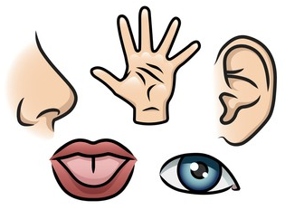  Don’t forget to use adjectives and expanded noun phrases. | Date:  Comments: | Create a Venn diagram to show similarities and differences between the Great Fire of London and the Great Fire of Edinburgh.  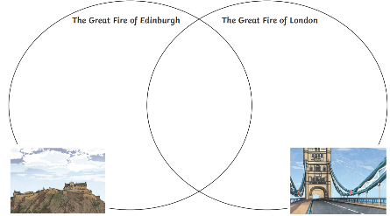 | Date:  Comments: | 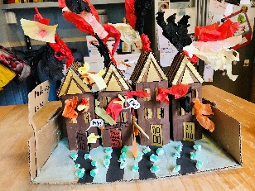  Use paint and other materials to create a diorama scene of the Great Fire of London inside a shoebox. Think about the key colours and characters you want to include. | Date:  Comments:
Research and make a fact file on one of these people:  - Thomas Farriner  - Christopher Wren  - King Charles II | Date:  Comments: |   Go to a bakery and buy something using coins and notes. | Date:  Comments: | 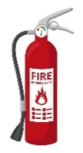  Whilst you are out and about, look around and see how many things you can see that are there to stop or prevent fires from spreading, for example, fire extinguishers and smoke alarms. | Date:  Comments:
  Interview an adult about their most special book. What makes it special to them? How do they feel when they read or think about it? | Date:  Comments: |   Research and try out a baking recipe. Take a photo of your edible creation! | Date:  Comments: | 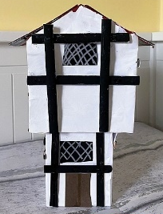  Make a model of a church or house in London in 1666. You could use recycled materials, building blocks or a range of things all together! | Date:  Comments:
Design an information poster to promote fire safety. Label your pictures and diagrams. Include a list using commas.  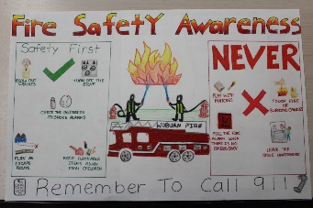 | Date:  Comments: | Get your adult to give you a job, for example, getting dressed or tying shoelaces.  Time yourself and see if you can beat your time every day that week.  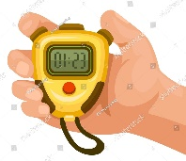 | Date:  Comments: | Make a 3D model of a London landmark in modern times.  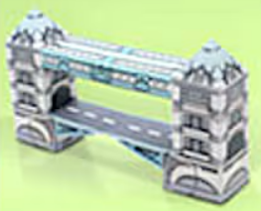 | Date:  Comments:
Homework Grid Summer 1 Great Fire of London
Please choose one activity a week, and record which activity has been completed by adding the date into the box provided. Please add comments, should you wish to, regarding your child’s engagement/enjoyment/understanding of each activity. Please choose at least two from each column during each half term.

