English |  | Maths |  | Topic/Creative
Describe a day at the seaside, thinking about the different senses. Try to paint a picture in the mind of the reader.  Year 1: remember to use capital letters and full stops and exciting adjectives.  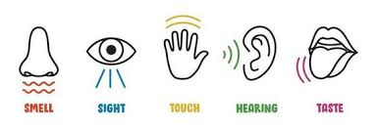  Year 2: use alliteration and similes. | Date:  Comments: |   Research a recipe on the internet or in a recipe book and make a milkshake or smoothie!  Take a picture and record in your homework book the amounts of each item you used e.g. 250ml milk, 2 bananas. Remember to measure accurately! | Date:  Comments: | Create a poster or leaflet about the ways we can look after the beach environment for other people to enjoy.  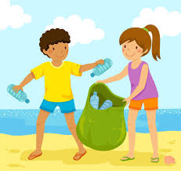  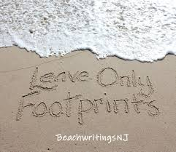 | Date:  Comments:
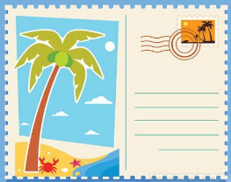  Write a postcard to a friend from somewhere you have been to on holiday or visited before. Remember to include details of what you have done and other information like what the weather has been like and what you are doing next. | Date:  Comments: | Look around your house or garden and go on a shape hunt!  Year 1: Look for 2D and 3D shapes and write down their names.  Year 2: Look for 2D and 3D shapes, write down their names and properties (sides, faces, edges, vertices). | Date:  Comments: |   Compose some music you could listen to at the seaside. Use body percussion, musical instruments or your voice. Perform it to family or record it and send it in to the office to pass onto teachers. | Date:  Comments:
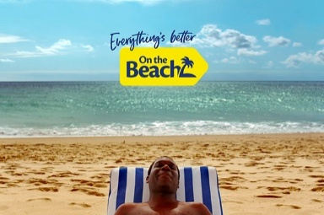  Pretend you work in a Travel Agents and create an advertising leaflet about a seaside place you would like people to visit.  Do some research using books or the internet to include pictures, maps and fun facts! | Date:  Comments: | Create a map or route for your toys, writing down the directions they need to follow, or give directions to a family member to arrive somewhere.  Year 1: include directions for forwards, backwards, whole and half turns and left and right.  Year 2: include directions for moving forwards and backwards and making quarter, half, three-quarter and whole turns, both in a clockwise and anticlockwise direction. | Date:  Comments: | Create a new animal, which is well adapted to live on the beach.  Think about what it will need to live in the sand or sea. What will it eat? Will it be camouflaged? Write a fact file in your book.  Year 1: picture with labels.  Year 2: captions to explain the adaptations and your choices. | Date:  Comments:
Use the internet to research a seaside town in another country and create a fact file.  You could find information such as, history, famous people, special places to visit and what there is to do. Present this in an exciting way to make people want to read about it! | Date:  Comments: | 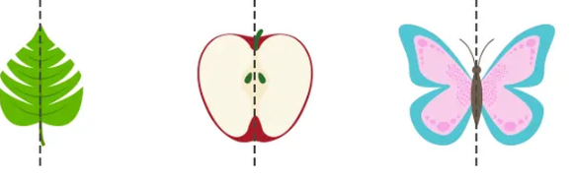  Look for lines of symmetry in nature or around your house e.g. plants, toys, items of furniture. Record this by drawing pictures of the things you find showing the lines of symmetry. | Date:  Comments: | Create a collage of the seaside using a range of materials, e.g. papers, fabric scraps, lentils, rice, cling film and natural materials to show different colours and textures.  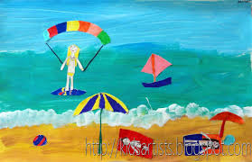  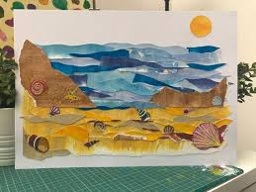 | Date:  Comments:
KS1 Homework Grid: The Seaside - Geography
Please choose one activity a week and record which activity has been completed by adding the date into the box provided. Please add comments, should you wish to, regarding your child’s engagement/enjoyment/understanding of each activity. Please choose at least two from each column during each half term.

