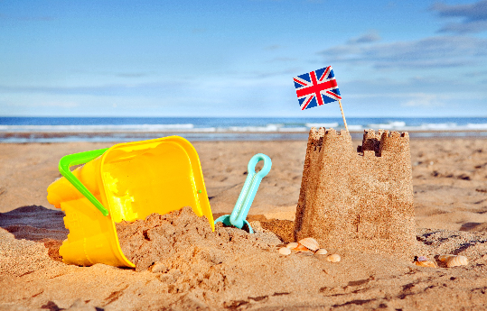
The Seaside- Geography
Sycamore and Silver Birch Classes
Summer 1 2025
English
Writing
- Fiction – retelling stories from the point of view of a different character.
- Y1 focussing on applying phonic knowledge and alternative sounds when writing new words, plus opportunities to demonstrate our knowledge of sentence writing.
- Y2 using commas in a list, and apostrophes within contractions and for singular possession (e.g., the girl’s hair).
- Handwriting – Y1 focussing on letter formation, Y2 focussing on developing our joined script, with well-sized finger spaces.
- Spelling – Y1 revising all sounds learnt ready for Year 1 phonics check. Y2 continuing our phonics spelling programme learning about suffixes and word groups to support spelling, as well as continuing to learn common exception words. Spelling tests continue each week for Year 2.

Reading
- Whole class reading activities linked to our focus texts.
- Focusing on comprehension and reading with understanding of texts.
- Y1 practising decoding skills for unknown words.
- Y1 focusing on the application of phonic strategies in preparation for Year 1 phonics screening.
- Y2 answering questions, making predictions and making links between different stories, characters and themes.

Mathematics
- Place Value – Y1 counting forwards and backwards to 100, positioning numbers on a number line, finding one more and one less.
- Addition and subtraction – Y1 using efficient strategies up to 20, Y2 solving addition and subtraction with two two-digit numbers.
- Multiplication and division – Y1 skip counting in 5s, 1- step problems using concrete apparatus, finding half of a quantity, Y2 recalling and using facts in the 2-, 5- and 10-times tables.
- Problem-solving – within a range of contexts, including capacity, time, money, and open-ended investigations.
- Geometry – Y1 3D shapes, Y2 using mathematical vocabulary to describe position, direction, and movement.
- Measure – Y1 telling the time to o’clock and half past, measuring and comparing compacity and volume with non-standard units (Y1), and standard units (Y2)

Science
Year 1: Animals including humans:
- Identifying, naming, drawing and labelling the basic parts of the human body and saying which part of the body is associated with each sense.
Year 2: Plants:
- Identifying what plants need to grow and be healthy and how different plants are suited to their habitats.
- Identifying the parts of seeds and bulbs and how these germinate and grow into plants.
- Describing the life cycles of plants.

R.E Ideas about God
- What do we think God is like?
- Judaism - stories from the Jewish faith and what they tell us about how Jewish people see God.
- Comparing Christian and Jewish views of God.

Geography
- Learning about the 7 continents and 5 oceans.
- Identifying seaside locations around the UK and the physical and human features of the seaside.

Music - Boomwhackers
- Learning about the musical elements of ‘pitch’ (high and low sounds) and ‘duration’ (long and short sounds).
- Using boomwhackers to produce rhythmic and melodic patterns.

P.E.
- Striking and fielding – skills for rounders and cricket.
- Athletics – running, high jumping, long jumping and shot put.

Computing
- Knowing what an algorithm is.
- Programming a sequence to make a Bee-Bot move.

PSHCE
- Thinking about what is special and unique about us.
- Respecting other people’s similarities and differences.
- Recognising what bullying is and what to do about it.

DT – Dips and Dippers
- Explaining the different food groups and knowing they have to eat a balance of foods to have a healthy
and varied diet.
- Designing a new product that is appealing to
themselves and others.
- Exploring and evaluate existing products.

Role Play Corner: A seaside shop

Vocabulary: senses, plants, habitats, life cycle, germination, growth, physical, human, features, continent, ocean, resort, tourist, pier, promenade, dippers, dips, appearance, texture

