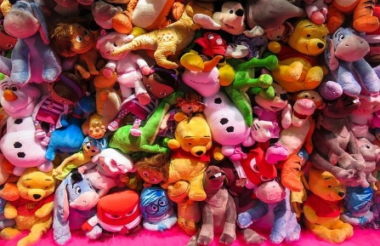
Toys!

Sycamore

Autumn 2 2025

English
Writing
- Toy-themed texts
- Key skills – focusing on using a range of sentence types, as well as conjunctions (and, because, when, if, so, but)
- Handwriting – continuing to focus on joined hand-writing, thinking about the size of our writing and the relationship between the lower-case and upper-case letters,
- Spelling - building on existing phonics knowledge and introducing alternative sounds as well learning new spelling rules and patterns.

Reading
- Whole class reading activities linked to our focus texts and other similar texts
- Focus on predicting and retrieving answers from a text.
- Continue to use our phonic skills to decode new words and use word patterns to help us with this (linked to spelling)

Mathematics
- Place Value – reading, writing and comparing numbers up to 100, counting in steps of 2, 5, 10s. Introduce counting in 3s.
- Addition and Subtraction – recalling known facts, adding / subtracting tens from 2-digit numbers.
- Problem Solving – solving multiplication, division and fraction problems using pictorial recording.
- Multiplication and Division - creating arrays and repeated addition, understanding the difference between sharing and grouping
- 2D / 3D Shapes – review properties and vocabulary, identify lines of symmetry in 2D shapes.
- Fractions – find ½ and ¼ of a 2D shape, count in fractional steps, recognise simple equivalence.
- Statistics – use tally marks to construct pictograms, interpret, ask and answer simple questions about pictograms and tally charts.

Science
- Identify and compare the suitability of a variety of everyday materials, including wood, metal, plastic, glass, brick, rock, paper and cardboard for particular uses.
History
- Comparing past and present toys alongside identifying and developing an understanding of the passing of time by using specific vocabulary associated with time.
- Use a range of sources as evidence.
- Develop questioning skills.

R.E
- Think about journeys we have been on.
- Consider the journey ends of Mary & Joseph, the Shepherds and the Wise Men in the nativity story.

PSHCE
- Understand what being healthy means, how to stay healthy, what they can do every day and who helps them stay healthy.
- Recognise that what we put in our bodies affects how we feel.
- Identify how medicines help people stay healthy.
- Find out why hygiene is important.

P.E
- Dance linked to toys and nativity
- Invasion games – football – dribbling, scoring, keeping possession

Computing
- IT skills – login / logoff, locate and use lower-case and upper-case letters, the space bar, the shift, backspace, delete and enter keys on the keyboard.

Design and Technology
- Investigate different wind-up toys.
- Design, make and evaluate their own wind-up toy.

Music
- Discover pitch and dynamics.
- Learn and perform songs for the Christmas Nativity.

Key Vocabulary

Science: material, properties, flexible, transparent, opaque, breakable, rigid, tough, waterproof, absorbent, suitability
History: past, present, timeline, decade, modern, old
R.E: journeys
PSHCE: healthy, hygiene, medicines
Computing: login / logoff, lower-case and upper-case letters, space bar, shift, backspace, delete, enter, keys, keyboard
Design and Technology: wind-up toys, mechanical, mechanism, wheel, axle, design, product
Music: pitch, dynamics, rehearsal, performance

