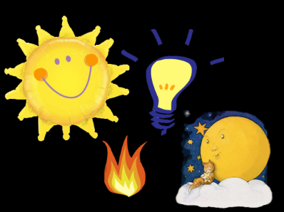

Light

In English, we will be…
- Reading and analysing a range of non-chronological reports.
- Reading a range of biographies on famous inventors.
- Exploring non-chronological reports and biographies with a focus on:
  - Writing for a purpose and awareness of the reader.
  - Using correct genre features.
  - Using correct punctuation and understanding how to use commas for clarity and effect.
  - Using formal language.
  - Using a variety of sentence structures including parentheses, relative clauses (Y5) and securing our ability to group relevant ideas together to form purposeful paragraphs (Y4).
  - Using a variety of sentence starters and cohesive devices including conjunctions and adverbials.
- Developing our skills of planning, self-editing and evaluation.

In our ‘English Grammar, Punctuation and Spelling’, we will be…
- Practising Y4 and Y5 spellings words.
- Spellings words with different prefixes, suffixes and identifying the root word.
- Revising verb tenses (simple, progressive and perfect forms), parentheses punctuation, adverbials, hyphens and clauses.
- Learning about using apostrophes for contractions and possession and understanding plurals.
- Reviewing our learning of punctuation including commas to clarify meaning or avoid ambiguity, the different word classes, noun phrases for concision and the use of hyphens to avoid ambiguity.

In Mathematics, we will be…
- Calculations and problem solving: practising mental strategies; securing formal written methods for all four operations; using the RICE (Read/Reflect/Record, Illustrate, Calculate/Check and Explain) strategies for solving methods, using the CPA approach (Concrete, Pictorial, Abstract) to solve problems and using models to reason appropriately.
- Place Value: solving Roman numerals problems, identifying and completing sequences and applying all place value skills.
- Statistics: Revising Venn and Carroll diagrams - exploring data and representing data; understanding, interpreting, and constructing line graphs (introduced to Y4).
- Measure: Solving time and timetable problems.

In Science, we will be…
- Learning about light including light sources, reflectors and mirrors, shadows, how we see and light through water.

In PE, we will be…
- Practising our striking and fielding skills when playing cricket (with Mr Bint).
- Focusing on athletics skills.

In DT, we will be…
- Designing, experimenting, making and evaluating a bedside lamp using an electrical system.

In PSHCE, we will be…
- Completing our ‘keeping safe’ unit.
- Learning about our future and the world of work (to continue in Summer 2).
In Music, we will be…

Learning to play the Ukulele and staring to learn the songs for our End of Year Production (with Mrs Rennison).

In RE, we will be…
- Understanding the significance of rituals for Muslims during the festivals of Ramadan and Eid-ul-Fitr.

In Computing, we will be…
- Using an art program to explore a range of techniques to create desired effects.
.

Science vocabulary: light source, dark, reflect, reflective, mirror, shadow, block, absorb, direct/ direction, transparent, opaque, translucent, straight, rainbow, colours, etc.
DT and Science vocabulary:
electricity, mains, battery, power source, circuit, lamp, wire, crocodile clips, resistor, insulator, cell, motor, conductor, insulator, switch, battery, buzzer, series, parallel, voltage, current, etc.

