Year 1 and Year 2 Autumn 1 Homework Grid: Wheels, Wings and Water!
Please choose one activity a week, and record which activity has been completed by adding the date into the box provided. Please add comments, should you wish to, regarding your child’s engagement/enjoyment/understanding of each activity. Please choose at least one from each column during each half term.
English |  | Maths |  | Topic/Creative
Write a recount of an exciting journey you have been on! This might have been to somewhere exciting, or maybe you travelled using different forms of transport.  Year 1 concentrate on capital letters and full stops.  Year 2 concentrate on adding an exclamation mark, capital letters and full stops. | Date:  Comments: | Set up a pretend shop in your house. Ask people in your family to buy items from your shop that cost e.g. 20p. Check they give you the right money, or make sure you give them the correct change!  Year 1 add 2 amounts together  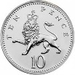  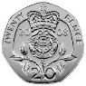  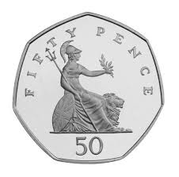  Year 2 add 2 amounts together and then have a go at finding change. | Date:  Comments: | 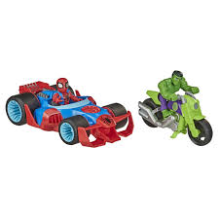  Collage a picture of a vehicle fit for a superhero! Choose your favourite superhero (or make one up) and design something that will help them to do their job well. Think about colours, logos and how to make it special. | Date:  Comments:
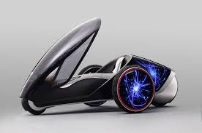  Design a new futuristic vehicle! Will it have wings, wheels or travel on water? Draw a picture and then write labels and captions to describe it. Consider how it moves, what it will be used for, etc.  Year 1 add labels.  Year 2 add labels and captions. | Date:  Comments: | Practice your maths activities.  Year 1 Number bonds to 10.  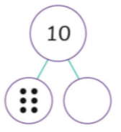  Year 2 Activities in your Mental Maths booklets.  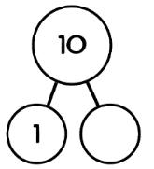 | Date:  Comments: | Research your favourite type of vehicle. When was it first invented, and by whom? How has it changed since then? Record the facts you find out in your homework book. You could draw a picture or some diagrams to help explain it too. | Date:  Comments:
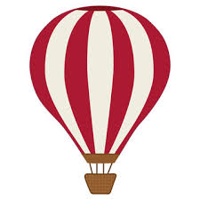  Make up and write a story about an adventure you could have in a hot air balloon. Where will you go? What will happen? Remember every story has a problem that needs fixing... how will things turn out alright at the end? Remember descriptive language.  Year 1 add adjectives.  Year 2 add an expanded noun phrase. | Date:  Comments: | Star numbers - how many ways can you make a number? Choose a 2-digit number and write it in your homework book. Now see how many calculations you can think of to get that number as your answer. For example, with the number 12, you could have 10 + 2, 20 – 8, 6 + 6, etc. You could repeat with different numbers too!  Year 1 add.  Year 2 add and subtract. | Date:  Comments: | Plan a journey to the most amazing holiday destination of your choice! In your homework book, you could record what you could pack in your suitcase, think about how you would travel and record that, and even make yourself a passport and ticket!  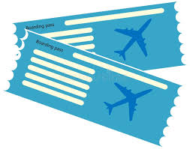  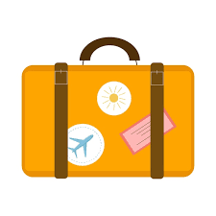 | Date:  Comments:
Design a road safety poster. Talk to a grown up about the rules of keeping safe when crossing the road, and make a bright, eye-catching poster to help other children learn. Use subheadings and captions to help you make the rules clear.  Year 1 remember capital letters.  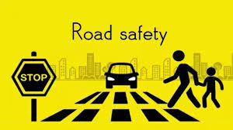  Year 2 add a question mark and an exclamation mark. | Date:  Comments: | Design a map for your favourite type of vehicle. Add lots of obstacles, then plan and record different routes around the map. Use directional language to describe where you want to go to get from the beginning to the end e.g. forward 5 steps, 1/4 turn right, 7 steps.  Year 1 full and half turn left and right.  Year 2 full, half and quarter turns left and right. | Date:  Comments: | 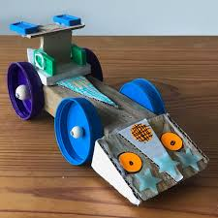  Make a 3D model of your favourite type of vehicle. You could do junk modelling, or make it out of a type of building material like Lego. Remember to take a photo to stick in your homework book!  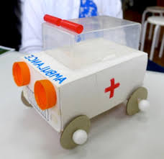 | Date:  Comments:

