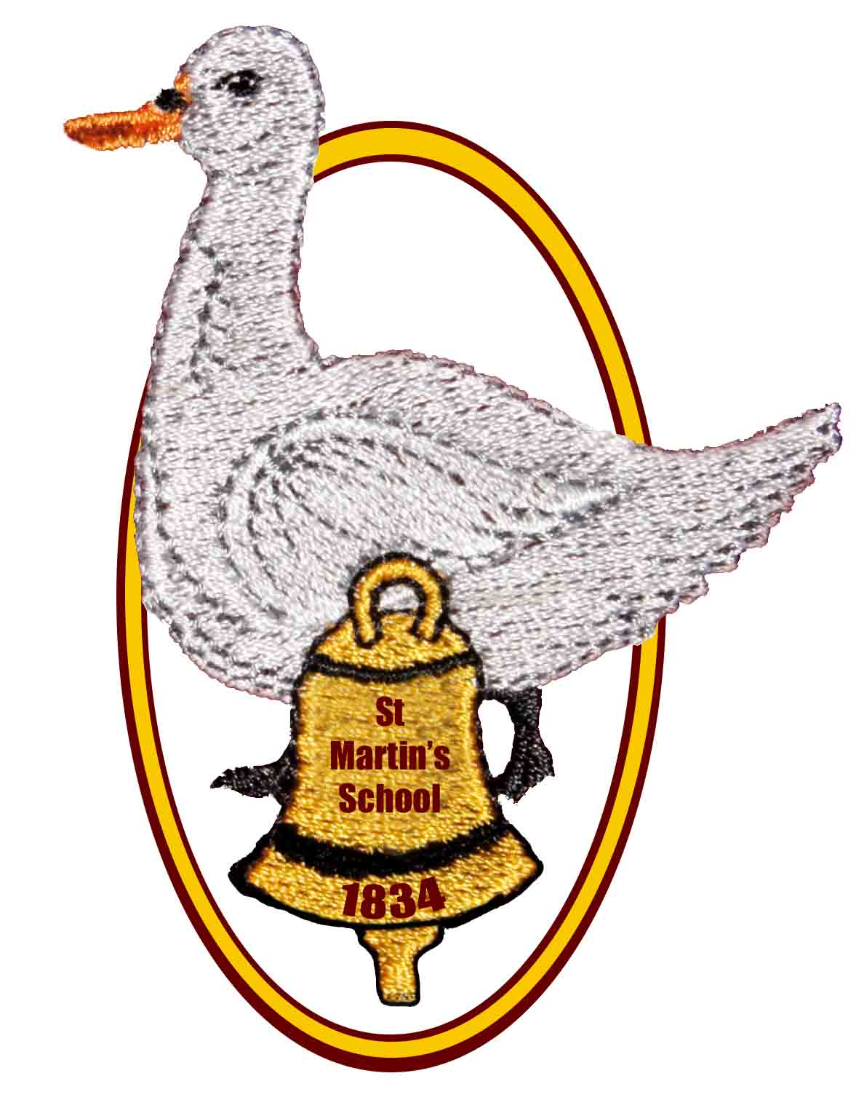
St Martin’s School
Headteacher: Mrs K. Bartlett Chair of Governors: Mrs A Rowe and Mrs L Chorley

OPEN MORNING, AFTERNOON AND EVENING

for parents of children who are due to start school in September 2022

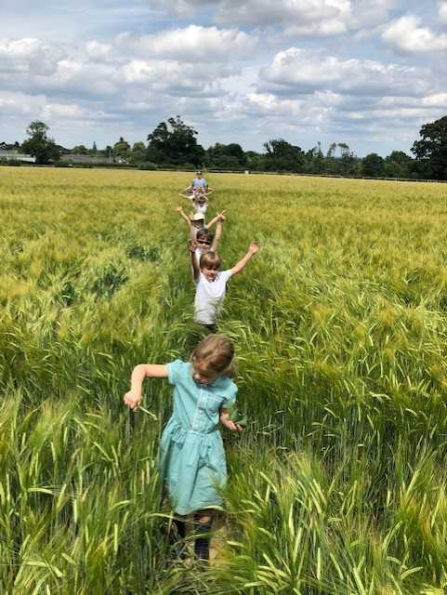
We would like to invite you to find out more about

St Martin’s

Church of England (Aided)

Primary School

East End, Newbury, RG20 0AF

on

Thursday 4th November
9.30am, 1:30pm or 6.00pm

We are planning to start each session with a short presentation by the Headteacher and Deputy Headteacher, followed by a tour of the school led by our school ambassadors and an opportunity to look round the school grounds.

We are asking anyone who would like to attend, to phone the school and book in to a session. This will allow us to monitor numbers and complete an accurate risk assessment and ensure we keep everyone as safe as possible in the current circumstances.

In the meantime, please explore our school website to find out more about us – the page for Cherry Class 2020 shows you how we supported our new Year R children last year and the staff films can give you a feel for the ethos of our school.
If you have any questions or would just like a chat with the Headteacher about St Martin’s School, please contact us on 01635 597796
or e-mail
adminoffice@st-martins.hants.sch.uk

Come and see our new Year R outdoor area, which is being installed during October 2021!

