Cherry Class
Summer Term 1 2025
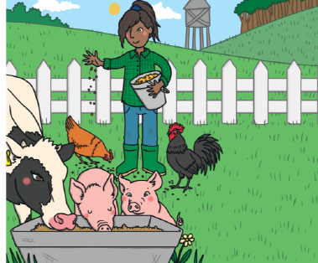
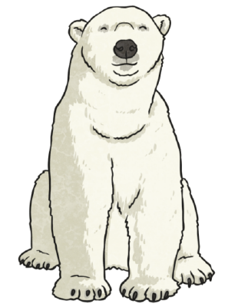
The World Around Us
Here is a brief summary of our planned learning for this half-term.

Communication, Language and Literacy
Ice bear book – labelling polar bears and polar bear facts
Emperor’s Eggs – penguin fact file
Rainforest Adventure – describe an animal by thinking of adjectives
Desert Region and describing animals who live there
Thank you letters for farm trip
Farmer Duck – retell story

Mathematics
Number bonds to 5 and 10 – using number frames and bead strings
Doubling and halving
Adding and taking away using a number-track
Take away – farm animals in the field

Physical Development
Gym: Taking weight on different body parts
Dance – around the world

RE
Special clothes – Judaism

Understanding the World
Looking at maps/globes
Farm visit
Looking at different areas of the world e.g. the Polar Regions, desert, rainforest

Expressive Arts and Design
Polar bear/Penguin art
Collages of different regions
Music for desert/artic/rainforests environments - listen and compose
Farm animal paintings

PSE
We are all different

