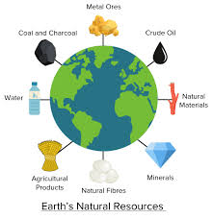
Willow Homework Grid: Natural Resources
I I did this independently with no help.
S I did this with some support.
H I needed lots of help and found it tricky.

English |  | Maths |  | Topic/Creative
Writing:  Can you find a story from another culture that contains a moral lesson/dilemma or message and innovate it to reflect your everyday life and experiences?  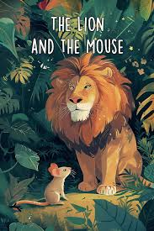  Challenge: have a go at writing it for two different audiences based on age – what will you need to change? Think about vocabulary sentence structure, use of speech and illustrations. | Date:  Comments: | Place Value: can you explore all the possibilities?  1) In a 6-digit number, the sum of the digits is 25.  a) What is the smallest number you can make?  b) What is the second smallest number you can make?  2) In a 7-digit number, the sum of the digits is 36.  a) What is the largest number you can make?  b) What is the second largest number you can make?  3)In a 5-digit number, the sum of the digits is 22.  The tens digits is 6.  a) What is the largest number you can make?  b) What is the smallest number you can make?  4)In a 7-digit number, the sum of the digits is 23.  The millions digit is 3 and the thousands digit is 5.  a)What is the largest number you can make?  b)What is the second largest number you can make? | Date:  Comments: | Geography: Can you create your own mind map to show how you rely on fossil fuels for different aspects of your life. Here is a template idea.  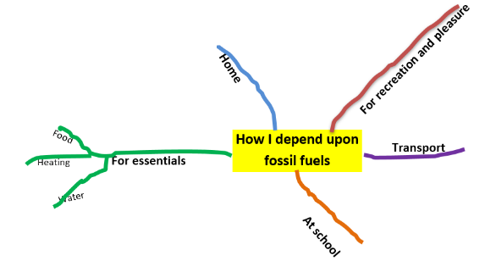 | Date:  Comments :
 |  |  |  | 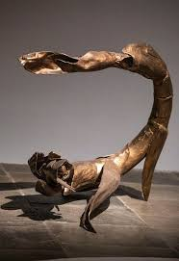  DT: Using the natural resources available to you in your garden or local community (check with and take advice from your adults about what, where and when is safe) to create your own sculpture that you think reflects your personality. | Date:  Comments:
Grammar:  Create your own game/flash cards to revise your knowledge (and test other people’s) of different word classes.  - Nouns  - Adjectives  - Verbs  - Adverbs  - Prepositions  - Determiners | Date:  Comments: | 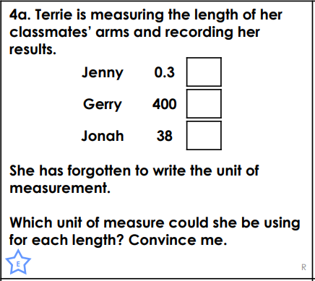  Measurements:  A long distance runner usually runs 30km in 5 hours. If he runs at an even pace throughout, how many metres should he have run after 75 minutes? | Date:  Comments:
Reading:    Find an explanation text and explain how its features, including the layout, help to support the reader and ensure it meets its purpose. | Date:  Comments:
 |  |  |  | PSCHE / Family Discussion activity:  Interview 2 members of your family about their thoughts on chores/jobs. Pose them the following options and ask for their reasons why:  - I don’t get paid for chores - why should you?  - Some chores should be done for free but a few could be paid for.  - All chores should be paid for instead of getting pocket money.  - You should get pocket money but do chores for free.  - You should get pocket money AND get paid for all chores.  Why do you think this? | Date:  Comments:
 |  | Geometry:  Draw a floor plan of a room in your house onto squared paper (or create your own grid with a ruler using equal and accurate intervals). Label the coordinates on the x and y axis. Then, create a list of challenges for someone to:  A: translate the different objects in the room a new position.  B: determine the translation when given new coordinates for an object. | Date:  Comments:
Spelling Practice:  Take some time to look at the word list in the back of your homework diary. Which words do you need to focus on for spelling? Take some time to focus on learning these (you could use the spelling techniques we learnt in class).  Write 6 sentences using at least one word per sentence. | Date:  Comments:
Date:

Comments:

