Willow Homework Grid: Vikings – Traders or Raiders?
I I did this independently with no help.
S I did this with some support.
H I needed lots of help and found it tricky.

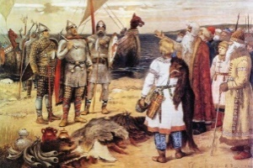
Please choose one activity a week, and record which activity has been completed by adding the date into the box provided. Please add comments, should you wish to,
regarding your child’s engagement/enjoyment/understanding of each activity. Please choose at least two from each column during each half term.
English |  | Maths |  | Topic/Creative
Reading and EGPS:  Choose a page from a book that you are reading. Create a table with these headings in your book. Identify the different grammar terms and record them in the table.  Expanded noun phrases Relative clauses Adverbs / adverbials  Determiners Pronouns Conjunctions  Prepositions Parentheses Powerful verbs  Challenge: Examples of simple, progressive and perfect tense forms. | Date:  Comments: | Fractions: TO DO AFTER OUR FRACTIONS LESSONS  Use these fractions to solve the following questions.  A B C D  a) Convert them into mixed numbers.  b) Show each fraction as a diagram/illustration.  c) Put them in order from smallest to greatest.  d) Add A and B together.  e) Subtract D from C.  Challenge: What is B + = 6.5? | Date:  Comments: | 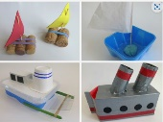  Science and DT activity:  Create different boats using different junk modelling materials including paper, cardboard, foil, lolly sticks, etc. You could research a Viking longship and use this is a model. Investigate which boat shape is best, by blowing it gently and watching it ‘sail’ across the bath/tub of water. Record your findings by either measuring the distance it moves or how long it stays afloat. Feel free to create your own science investigation and explore ‘water resistance’. | Date:  Comments:
 |  |  |  | Computing activity: https://scratch.mit.edu/  Use this website to make your own Scratch game using your coding skills. Remember to check out the tutorials at the top to help you and give you tips. | Date:  Comments:
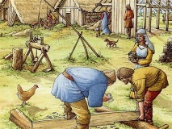  Writing:  Write a diary entry for a monk or a slave that has witnessed a Viking raid. Ensure you write in the first person, recount the day’s events and what you saw, include the character’s thoughts and feelings, use the past tense and please use PUNCTUATION! Please read your writing to check it makes sense. | Date:  Comments: | 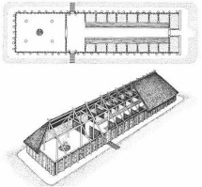  Area and Perimeter: TO DO AFTER OUR AREA AND PERIMETER LESSONS  Design the interior of a Viking longhouse from a birds-eye view. Work out the area and perimeter of the shapes that you create to stand for the different parts of the house (table, beds, animal area, stools, fire place, etc). | Date:  Comments:
 |  |  |  | 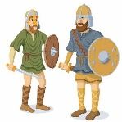  History activity:  Design and prepare your Vikings / Anglo-Saxons outfit for our Vikings day. You can dress up as Anglo-Saxons (farmers, blacksmiths, monks, slaves, anyone from the 800AD to 1066 period) or a Viking that has crossed the sea. | Date:  Comments:
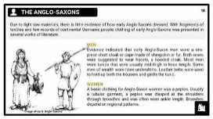  Writing:  Create an information booklet / sheet / poster / PowerPoint about the Anglo Saxons. This could be done over a few weeks. You can use the following subheadings to research and include: Who were the Anglo Saxons? Where and when did they live? Who was Afred the Great? Other aspects you can include: clothes, homes, food, etc.  Y5: Use correct punctuation, paragraphs and formal language. | Date:  Comments: | Mental Maths Practice:  Pick two numbers and multiply them mentally. Complete at least 20 calculations. Record your answers and use a calculator to check!  400 30 800 2000  8 6000 60 40  5 70 20 80  700 900 9 300  Challenge: Investigate what happens when you multiply decimal numbers. Can you use the times tables facts you know to work out decimal multiplications and divisions? For example, 0.007x0.3=0.0021 or 5.4÷0.9=6 | Date:  Comments:
 |  |  |  | PSCHE / Family Discussion activity:  Carefully discuss what you and your family would do, if there was a fire in your house. What fire safety precautions do you have in place? Do you know your escape routes? Do you have a fire safety plan and have you practised it? This website might help: https://www.london-fire.gov.uk/safety/the-home/ | Date:  Comments:
Spelling Practice:  Please learn the following words by creating a wordsearch or a crossword showing the correct spelling of the Y5/Y6 words (government to muscle).  Please learn: government, guarantee, harass, hindrance, identity, immediate(ly), individual, interfere, interrupt, language, leisure, lightning, marvellous, mischievous and muscle. | Date:  Comments: | Mental Maths: Purple Mash  Complete the Purple Mash activities on ‘missing angles’. The tasks have been set as a ‘2Do’ for you. You will need to remember the angle rules: angle around a point=360°, angles on a straight line=180°, right-angle=90° and vertically opposite angles are equal. | Date:  Comments: | 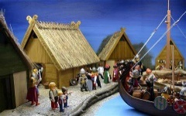  DT and History activity:  Design and make a 3D diorama for a typical Anglo-Saxon / Vikings scene. A diorama is usually a shoebox/open box that models a miniature version of a scene. | Date:  Comments:

