Make a Time Capsule
We are living in interesting times; the year 2020 is sure to go into the history books!
What would you like historians in the future to know about this year?
What messages would you like to send to the grown-up you?
Why not make a time capsule, to show people in the future what life is like and what’s happening in the world in Spring 2020?
First, find a suitable container, such as a biscuit tin or lunch box and decorate it. Then collect some items together, that will tell people in the future some of the things that are important in the present day.
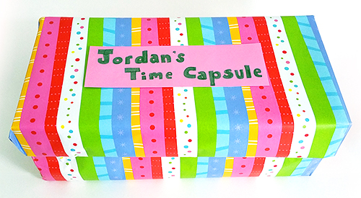

Here are a few ideas to get you started, but you can probably think of lots more interesting things to include!

Draw a self-portrait and add labels to show some interesting things about yourself, such as Quick feet for scoring goals or Musical mouth for singing.
Draw a picture of your family and friends as they are today, or include a photo. Add notes to show who’s who and give some interesting facts about them.
Make a list of your favourite things and people, such as food, books, films or games. OR, write a letter to your grown-up self. Write about what’s happening in your life and in the world, how you feel and your hopes and dreams for the future. What advice would you give yourself that would be useful when you open the capsule in 10 or 20 years’ time? (Perhaps an adult at home would write you a secret letter to add to your time capsule?!)
Cut out some newspaper articles about things that are important in the world at the moment, or print some from the Internet.
Take some pictures of today, print them and put them in your time capsule.

Collect a few small objects, such as a wrapper from your favourite snack, a small toy or tickets from a special day out. (Don’t put in anything too precious, or that you’ll be needing in the next few years!)
Think of something that represents your values, or that shows what you think is important in life. (Clue: maybe think about your school values, or something you want to change in the world to make it a better place.)
These are just a few ideas, you can probably think of lots more to add to your time capsule; why not discuss it with someone at home?

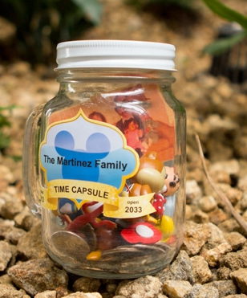
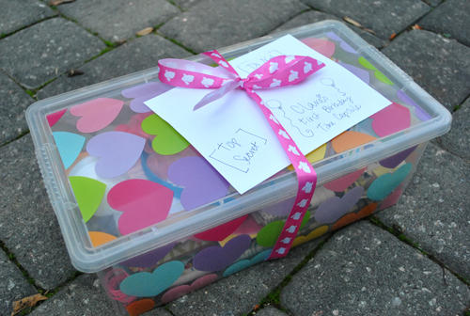

Now find a safe place to hide your time capsule, maybe at the back of a cupboard or in a shed. If it’s watertight, you could even bury it in the garden. You can decide how long you are going to wait, before you open your present to the future!




