Cherry Class
Spring Term 2: 2023
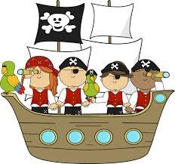
Pirates and Mermaids
Here is a brief summary of our planned learning for this half-term. But remember:
No plan in Reception is ‘set in stone’! BP KA

RE
The symbol of the cross
The Easter Story
Church Visit

Communication, Language and Literacy
The Night Pirates – reading focus
Letter from a pirate
Describe a pirate/mermaid character
Wanted poster for a naughty pirate
Message in a bottle and maps
Write an adventure story about a pirate/mermaid

Mathematics
Sharing pirate treasure fairly
Taking away pirate treasure
O’clock and how many times in a minute
Place Value – numbers above 10
Ordering numbers
Capacity – filling bottles

PSE
Look at me now - what could we not do as toddlers that we can now do?
New goal/challenges

Understanding the World
Land and sea – pirate maps, compasses
Easter and how we celebrate
Use a programmable toy: Bee-Bot (Pirate Island)
Changes from birth until now

Expressive Arts and Design
Treasure maps
Oil pastel flowers
Easter gardens
Clay crosses
Mother’s Day and Easter Cards
Easter songs/Hosanna song

Physical Development
Ball skills
Funky fingers, dough disco and handwriting

