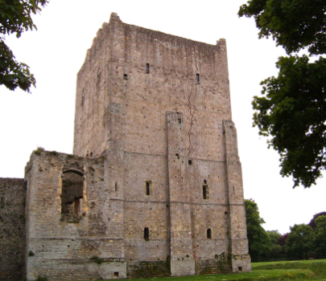

Castles!

Sycamore & Silver Birch Classes

Summer 2 2024

**English**

* Y1 focusing on forming letters correctly, thinking about the presentation of our writing, as well as embedding understanding of sentence punctuation and beginning to use question and exclamation marks.
* Y2 focusing on using a range of punctuation confidently, writing effectively and coherently and presenting our work in our best handwriting.
* Y3 focusing on using a variety of sentence structures, a rich and varied vocabulary and exploring and expanding our range of punctuation marks.
* Handwriting – Y1 focusing on letter formation, Y2 focusing on developing our joined script, with well-sized finger spaces and, for Y3, remembering to join all the time in our writing.
* Writing in different genres (e.g. recounts, stories, diaries, instructions, non-fiction texts etc.) and for Y2 and Y3, thinking about the writing style and ‘the reader’.
* Spelling – continuing our spelling programme embedding our understanding of year group specific suffixes, prefixes and word families for Y3, as well as continuing to learn common exception words for each specific year group.

**Reading**

* Whole class reading activities linked to our theme of Castles.
* Focus on comprehension skills in a range of ways.
* Y1 continue applying phonic skills in preparation for Y1 phonics screening.

**Mathematics**

* Consolidating using all four operations to solve problems (Y1 within 20, Y2 within 100, Y3 within 1000), both 1-step problems and 2-step problems.
* Y3 consolidating both mental and formal written calculation methods (including grid for multiplication and chunking for division) as well as improving mental strategies for calculation.
* Problem-solving – using and showing our reasoning, within a range of contexts, including measures, time, money and open-ended investigations.
* Geometry – consolidating understanding of the properties of 2d and 3d shapes, and Y3 using the terms acute and obtuse for angle properties
* Measurement - reading a range of scales showing temperature, capacity, length and weight
* Time - becoming more confident telling the time (Y1 o’clock and half past, Y2 nearest quarter hour, Y3 nearest minute) and solving duration problems
* Statistics – asking and answering questions about data, with increasing complexity, dependent on year group.

**Science**

**Pushes and pulls, magnets**

* Comparing how things move on different surfaces.
* Noticing that some forces need contact between 2 objects but magnetic forces can act at a distance.
* Observing how magnets attract or repel each other and attract some materials and not others.
* Comparing and grouping together a variety of everyday materials on the basis of whether they are attracted to a magnet and identifying some magnetic materials.
* Describing magnets as having two poles.

**PSHCE**

* Identifying ways for keeping physically and emotionally safe.
* Recognising that we share a responsibility for keeping ourselves and others safe.
* Describing our feelings, reflecting on the past year, and looking towards next year.

**P.E.**

**Athletics**

* Exploring different ways of throwing, showing awareness of space and safety.
* Developing the quality, range and consistency of the techniques used for running, throwing, catching and dribbling.
* Improving the quality and control of their skills by giving and receiving feedback from their peers.

**Striking and Fielding (Cricket and Rounders)**

* Understanding and identify good striking and fielding techniques.
* Combining skills to play effectively in a small sides striking/fielding game and using simple attacking and defending tactics e.g. work as a team to field the ball.

**DT**

* Designing and making a working drawbridge, identifying the reasons castles used these as a defense system.

**History**

* Recognising and naming the features of a castle.
* Understanding the different roles within a castle and hierarchy.
* Comparing the reigns of two monarchs in history.
* Exploring the life of King Charles III and putting his key life events in chronological order.

**Computing**

* Exploring a range of simulation programs and games.
* Searching for castle related images to import.
* Using the ‘Paint’ app to annotate a digital picture.

**R.E**

* Finding out what the creation story tells us about God and human beings.
* Describing examples of what Christians do to care for the world.

**Art and Design**

* Researching royal portraits and collecting and developing sketches and drawings.
* Recognising and naming the primary, secondary and some tertiary colours.
* Using, recognising and describing lines, patterns, textures and basic shapes in their work and the work of other artists.

**Music**

* Recapping the musical elements of structure, dynamics and tempo.
* Composing music using a castle video as stimulus.

**Role Play Corner:** In the castle keep!

**Key Vocabulary:** castle,monarch, drawbridge, turret, moat, portcullis, armour, tower, trebuchet, fortress, shield, ramparts, noble, dungeon, King, Queen, royal, portrait, magnet, pole, force, repel, attract