English |  | Maths |  | Topic/Creative
Look at the view from your bedroom window. Think like an author and write a description of what you can see. Don’t forget to think about the reader and make it exciting and detailed!  Year 1 – include adjectives  Year 2 – include similes and alliteration | Date:  Comments: | Search your garden for plants of varying size. Then measure their height and order them from smallest to tallest.  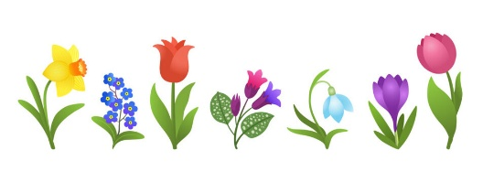  Year 1 – use non-standard units of measure e.g. hands, cubes.  Year 2- use a ruler to measure in cm. | Date:  Comments: | Find out about recycling in your local area – what can you as a family recycle? What materials can or can’t be recycled, and in which colour bins? You could even research why some items can’t be recycled.  You could record this in your homework book or as a video and send it to the office to pass onto teachers. | Date:  Comments:
Write a song or rap about recycling and how important it is. Perhaps you could perform it to your family and friends.   | Date:  Comments: | Practice using money. Label a selection of objects with a price. Choose two items to buy and add them together (Year 1), then work out the change (Year 2):  Year 1 – items up to 10p  Year 2 – items up to 50p, then £1. | Date:  Comments: | Use junk modelling to create a collage or model – what can you create with what your family are throwing away or sending to be recycled? What could you make a collage or model of? Take a photo and stick it in your homework book or bring it in to show us! | Date:  Comments:
Write a poem about Spring. You could base it on a spring flower (daffodil, crocus, tulip) or on spring born animals (lambs, calves) or on the spring weather. It could be acrostic, rhyming, a riddle or free verse.  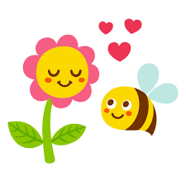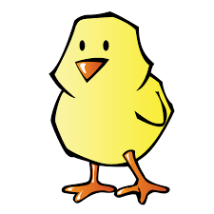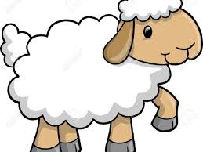 | Date:  Comments: | Practice your counting skills. Count forwards and backwards in each pattern, until you are fluent and confident.  Year 1 – count in 1s, 2s and 10s.  Year 2– count in 2s, 5s, 10s and 3s then use this to practice your 2x, 5x and 10x tables. | Date:  Comments: | Find a view you love, perhaps from your house or from a familiar landmark and draw it. You could use pencils, chalks, pastels, paint etc.     | Date:  Comments:
Do a word sort! Draw a grid in your homework book with 4 titles – nouns (e.g. tree, hand, names), adjectives (e.g. beautiful, scary), adverbs (e.g. happily, fast) and verbs (e.g. run, jump, skip).  Read your favourite story and see if you can find words to go in each box.  Year 2 – Which word types are easier/harder to find? Why do you think that is? | Date:  Comments: | Problem-solving activity – can you find all the solutions? I have 3 different coloured plants – one red, one yellow and one green. How many different ways/orders can I plant them?  Try not to have any repeats! How many ways can you find?  Year 2 – Now add a blue plant so there are four different coloured plants – how many ways can you find now? | Date:  Comments: | Make a poster telling people how to reduce, reuse and recycle. You could include pictures of what can and can’t be recycled, give rules to help people remember, or even make your poster on a computer and add pictures of the different bins. Make it clear, colourful and eye-catching!  Do this in your homework book or on a computer and print it out! | Date:  Comments:
KS1 Homework Grid: Eco Warriors!
Please choose one activity a week, and record which activity has been completed by adding the date into the box provided. Please add comments, should you wish to, regarding your child’s engagement/enjoyment/understanding of each activity. Please choose at least two from each column during each half term.

