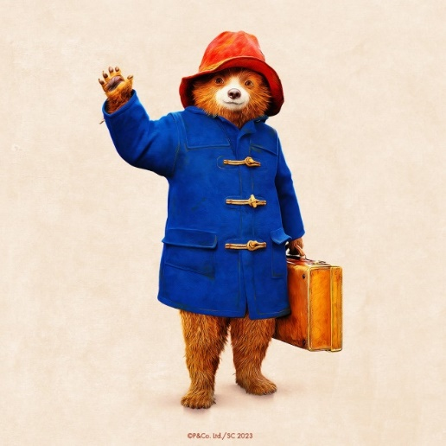

**Paddington**

Sycamore Class

Autumn 2025

**English**

* Focus texts – Paddington stories, non-fiction Spectacle bears
* Key skills – Focus on using a range of sentence types, as well as conjunctions (and, because, when, if, so, but) using correct punctuation for different sentence types.
* Handwriting – Think about the size of our writing and the relationship between the lower-case and upper-case letters.
* Phonics – Twinkl phonics
* Spellings will come home associated with the Twinkl Phonics programme weekly.

**Reading**

* Whole class reading activities, designed to support understanding of the text, the characters and the events, linked to our focus texts and similar texts.
* Continue to use our phonic skills to decode new words, and using word patterns to help us with this (linked to spelling).

**Mathematics**

* Place Value – count forwards and backwards to 100 in 1s, 2s, 5s, 10s. Continue to embed an understanding of 2-digit numbers. Read and write numbers to at least 100 in numerals and in words. Identify one/ten more and one/ten less of any given number using a hundred square and a number line. Compare and order numbers up to 100 using < , > and = signs.
* Addition / Subtraction – add and subtract 2-digit numbers using concrete objects, pictorial representations and mentally.
* Measures – estimate and measure length/height (cm) using rulers.
* Money – Recognise and use symbols for pounds (£) and pence (p); combine amounts to make a particular value. Find different combinations of coins that equal the same amounts of money.
* Problem Solving – Solve problems involving addition and subtraction, using concrete objects and pictorial representations, missing number problems and money of the same unit.

**P.E**

* Games - playground games
* Gymnastics - floor work – making up sequences involving balance, travel, shape

**Science – Everyday Materials**

* Distinguish between an object and the material from which it is made by naming specific objects and a range of materials, including objects that are made of more than one material.
* Identify and name a variety of everyday materials.
* Describe the simple physical properties of everyday materials.
* Use observations in enquiries to suggest answers to a question.

**Geography**

* Understand geographical similarities and differences through studying the human and physical geography of a small area of the United Kingdom - London, and of a small area in a contrasting non-European country – Lima, Peru.
* Use basic geographical vocabulary related to human and physical features.

**R.E – Bread as a Symbol**

* Communicate their understanding of bread and recognise how it can be used as a symbol.
* Focus on the significance of bread in the Christian Harvest Festival.

**PSHCE - Relationships**

* Participate in creating a class charter.
* Understand what makes a good friend.
* Explore healthy friendships and conflict resolution.

**Art**

* Design and create a bear’s face made from clay.
* Investigate different clay techniques.
* Describe and evaluate their artwork.

**Design and Technology**

* Design and make a healthy sandwich.
* Evaluate their product and any improvements needed.

**Music**

* Learn how to write simple rhythmic notation.
* Appreciate music from another culture - Peru

**Computing**

* Understand the computer agreement.
* IT skills – login / logoff, locate and use the letters of their name, and the space bar, shift, backspace, delete, enter on the keyboard.
* Develop their mouse and trackpad skills by creating artworks in Purple Mash.

**Topic Words**

Geography: human, natural, physical, world, country, continent, capital, village, atlas, border

Science: object, hard, soft, shiny, dull, stretchy, bendy, see-through, wood, metal, water, plastic, rock, glass, brick, paper, cardboard, fabric, rubber, material, properties, stiff, rough, smooth, transparent, opaque, waterproof, absorbent