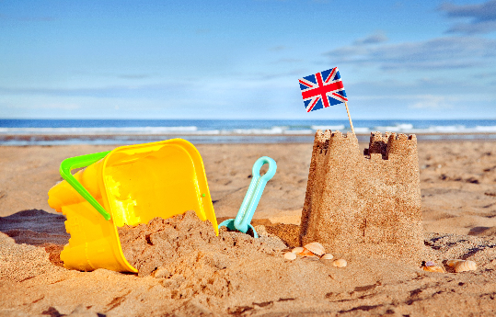

**The Seaside- History**

Sycamore and Silver Birch Classes

Summer 2 2025

**English Writing**

* **Y1** focusing on forming letters correctly, thinking about the presentation of our writing, as well as embedding understanding of sentence punctuation and beginning to use question and exclamation marks.
* **Y2** focusing on using a range of punctuation confidently, writing effectively and coherently and presenting our work in our best handwriting.
* Handwriting – **Y1** focusing on letter formation, **Y2** focusing on developing our joined script, with well-sized finger spaces.
* Writing in different genres (e.g. instructions, recounts, stories, diaries, non-fiction texts etc.), **Y2** thinking about the writing style and ‘the reader’.
* Spelling – continuing our spelling programme embedding our understanding of year group-specific suffixes, as well as continuing to learn common exception words for each specific year group.

**English Reading**

* Whole class reading activities linked to our focus texts.
* Focus on comprehension skills in a range of ways.
* **Y1** continue applying phonic skills.
* **Y2** reading with fluency and answering questions about the text, making predictions and making links between the book they are reading and other books they have read.

**Mathematics**

* Consolidating using all four operations to solve problems (**Y1** within 20, **Y2** within 100, including the 2, 5 and 10 times tables), both 1-step problems and 2-step problems.
* Problem-solving – using and showing our reasoning, within a range of contexts, including measures, time, money, position and open-ended investigations.
* Fractions – **Y1** finding a quarter of a shape and quantity.
* Geometry – **Y1** confidently recognising and naming 2D and 3D shapes, **Y2** consolidating understanding of the properties of 2D and 3D shapes
* Measurement - reading a range of scales showing capacity and weight, **Y2** including temperature and length.
* Money – **Y2** finding different combinations of coins that equal the same amounts of money and solving two-step money problems.
* Time - becoming more confident telling the time (**Y1** to o’clock and half past, **Y2** to five minutes including quarter past/to the hour) and solving duration problems.
* Statistics – asking and answering questions about data, with increasing complexity, dependent on year group.

**Science Seasonal changes**

* Observing changes across the four seasons.
* Observing and describing weather associated with the season and how day length varies.

**R.E Special Places**

* Thinking about places that are special to us and why.
* Describing how a Church is a special place for Christians and a Synagogue is a special place for Jewish people.

**History**

* Recognising similarities and differences between holidays now and in the past.
* Finding out about the past in different ways.
* Exploring vocabulary about the passing of time.

**Music – Boomwhackers / Recorders**

* Learning about the musical elements of ‘pitch’ (high and low sounds) and ‘duration’ (long and short sounds).
* Using boomwhackers and recorders to echo and produce rhythmic and melodic patterns.

**P.E.**

* Striking and fielding - exploring different ways of passing and receiving.
* Athletics – Sports Day practise.

**Computing**

* Internet safety.
* Using the internet, Purple Mash, email and google docs.
* Inserting text and pictures to a document, changing the size and position.
* Changing font, size and colour.

**PSHCE**

* Understanding who can keep us safe within the community and how we can keep ourselves safe.
* Reflecting on this year’s achievements and looking forward to next year.

**Art**

* Creating a seascape paper plate using sketching, drawing, crafting and painting, exploring different mediums to create different effects.

**Role Play Corner:** A seaside shop

**Topic Vocabulary**

Seaside, ocean, habitat, life process, shore, bathing costumes, bathing machines, seascapes, pirates, seasons, weather, daylight, autumn, winter, summer, spring, community, document, email, internet, internet safety