Cherry Class
Autumn Term 1 Year 1 2025
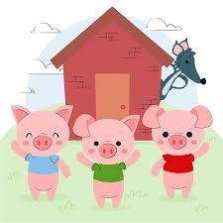
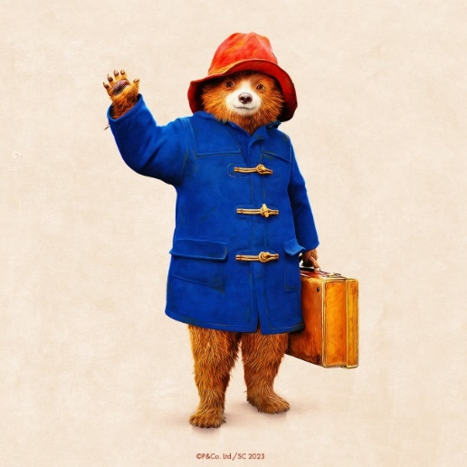

All About Animals
English
Oi Frog – Making rhyming sentences
The Three Little Pigs – re-telling story
Dear Zoo – speech bubbles
Owl Babies – Non-fiction facts
The Tiger who came to tea – character description
Twinkl Phonics – Level 5

Mathematics
Count forwards and backwards to 20
Count in 10s to 50
Given a number, identify one more and one less
Order numbers to 20
Compare and measure heights and length
Money – 1p and 10p coins

PE
Games – playground and bean bag games
Gym – sequences

Science – Everyday Materials
Identify and name a range of materials
Describe properties
Observations – suggest answers to questions

Geography
Understand geographical similarities and differences of a small area of the United Kingdom – London, and a small area of a contrasting non-European country – Lima, Peru
Use basic geographical vocabulary

Art/DT
Painting – self portrait
Tiger Mask
Drawing and painting tigers
Make a House for the Pigs
Clay – animals
Design and make a healthy sandwich for the tiger

Music
Learn how to write a simple rhythmic notation
Appreciate music from another culture - Peru

Personal, Social and Emotional Development
Class charter: rule and routines
Understand what makes a good friend
Explore healthy friendships and conflict resolution

RE – Bread as a Symbol
Communicate their understanding of bread and recognise how it can be used as a symbol
Focus on the significance of bread in the Christian Harvest Festival

Computing
Chrome Books – log in/log off
IT skills – locate and use the letters of their name, and the space bar, shift, backspace, delete, enter on the keyboard
Purple Mash – Develop their mouse and trackpad skills by creating artworks

Topic Words/Vocabulary
Geography: human, natural, physical, world, country, continent, capital, village, atlas, border
Science: object, hard, soft, shiny, dull, stretchy, bendy, see-through, wood, metal, water, plastic, rock, glass, brick, paper, cardboard, fabric, rubber, material, properties, stiff, rough, smooth, transparent, opaque, waterproof, absorbent

