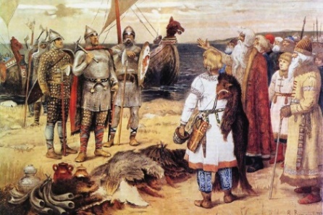

In English, we will be…
- Writing recounts of a Viking raid including diary entries and newspaper reports.
- Writing an opening for an adventure story that focuses on creating suspense.
- Practising our writing skills:
- Using the appropriate genre features and showing an awareness of the reader.
- Using the correct formal and informal tone.
- Using punctuation correctly. Y4: indicating words spoken using inverted commas. Y5: Using correct speech punctuation.
- Y4: Using a range of conjunctions to indicate time, place and cause.
- Y5: Varying sentence structures and using a variety of punctuation such as dashes, brackets and commas to add in relative clauses and using fronted adverbials.

- Developing our skills of planning and structuring our writing into paragraphs.
- Developing our skills of self-editing and peer-editing.

In our reading, we will be…
- Analysing, evaluating and identifying grammar, punctuation and vocabulary features in a text.
- Using and applying all our reading roles.
In our ‘English Grammar, Punctuation and Spelling’, we will be…
Y4:
- Using prefixes sub, super, inter, anti, auto, ex and non.
- Creating a soft c /s/ sound with ‘ce’ and ‘ci’.
- Noun phrases expanded by the addition of modifying adjectives, nouns and preposition phrases.
- Revising our knowledge of apostrophes – possessive and plural nouns.
Y5:
- Spellings words with different suffixes such as able, ible, ibly and ably, hyphenated words, silent letter words and homophones.
- Identifying adverbials and their function and different types of clauses.
- Reviewing our knowledge of the simple, progressive and perfect tense forms.
- Revising our knowledge of punctuation including apostrophes.

In Mathematics, we will be…
- Fractions: calculating fractions and converting fractions, decimals and percentages. Y4: adding and subtracting fractions with the same denominator. Y5: adding, subtracting and multiplying fractions and solving fraction problems; representing FDPs pictorially.
- Area, perimeter and volume: Finding and calculating the area and perimeter of shapes (including counting squares). Y5: also calculating volume.
- Place Value: Roman numerals. Y4: multiplying and dividing 1 and 2 digit numbers by 10 and 100. Y5: multiplying and dividing numbers by 10, 100 and 1000.
- Measure: Solving time and timetable problems.
- Calculations and problem solving: Using written methods for all four operations to solve problems. Using the CPA approach (Concrete, Pictorial, Abstract) to solve problems.

In Science, our topic will be…
- Learning about friction including air and water resistance.
- Reviewing our knowledge on forces and gears, levers and pulleys.

In Design Technology, we will be…
- Using our technical knowledge to understand mechanical systems.
- Designing, making, and evaluating a Viking Longboat.

In PSHCE, we will be…

Learning about keeping safe at home, in school, in our local community and online and identifying risks in these places.

In History, we will be…
- Learning about the Vikings and the Anglo-Saxons struggle for the Kingdom of England.

In French, we will be…

Learning to tell the time.

In Music, we will be…

Looking at the elements of duration, dynamics and tempo, including an Anglo-Saxon link, with Mrs Rennison.

In RE, our topic will be…

Investigating the concept of resurrection and what it means to different people (looking at Christianity and Humanism).

In PE, we will be…
- Developing our skills in net and wall games (badminton).
- Developing our skills in creative dance linked to our Vikings theme.

In Computing, we will be…
- Learning coding skills using Scratch.

Topic words for this term:
-Vikings, Scandinavian, Baltic, Iceland, Anglo-Saxons and empire; raiders, traders, invaders, settlements, slaves, warriors, pillage, voyagers, navigation; monk, monastery, freeman, blacksmiths, longship, thatched house, runes, longhouse and Norse language; sagas, descendants, myths, heathen and Gods.
Science words for this term:
-forces, friction, air resistance, water resistance, gravity, surface, mass, buoyancy, upthrust, etc.

