KS1 Autumn 1 Homework Grid: Our School, Our Village
Please choose one activity a week, and record which activity has been completed by adding the date into the box provided. Please add comments, should you wish to, regarding your child’s engagement/enjoyment/understanding of each activity. Please choose at least one from each column during each half term.

English |  | Maths |  | Topic/Creative
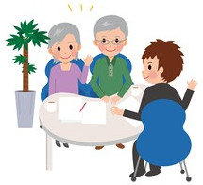  Write some questions to ask an older person about what it was like at their school. Interview them.  Year 1 concentrate on capital letters.  Year 2 remember to add question marks. | Date:  Comments: | 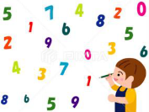  Practise your counting and number formation. Write numbers using different drawing materials such as pencils, felt tips and paints. Or why not take your learning outside and use chalks, water or paint to create giant numbers?  Year 1 numbers up to 20  Year 2 numbers up to 100 | Date:  Comments: | History Walk – take a walk around your local area, what can you notice that is from the past? For example, old buildings, statues, memorials plaques/signs. Take photos of what you find or draw pictures. Label them.  What can it tell you about the history of your local area? | Date:  Comments:
Draw, paint or find a picture of a Victorian School classroom. Write labels and captions to describe it. (Wait until after our Victorian Day!)  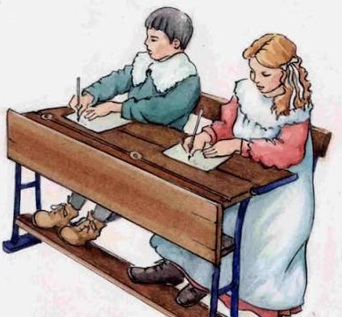  Year 1 add labels.  Year 2 add detailed labels to describe what it looks like using adjectives. | Date:  Comments: | Pretend you are in a Victorian School. Practise your number bonds on a chalk board or using chalk on a dark piece of paper.  Year 1 pairs that total 10.  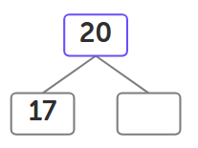  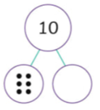  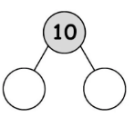  Year 2 pairs that total 20. | Date:  Comments: | 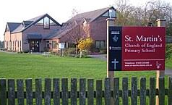  School Model – build a small replica of our school, St Martins or your favourite classroom using cardboard, blocks, or recycled items. | Date:  Comments:
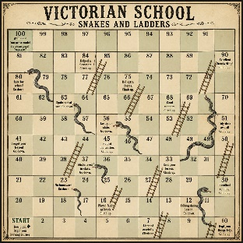  Create a Victorian School version of Snakes and Ladders. Write some new reasons why you might climb a ladder or slide down a snake. For example,  >Lost your slate. Go down.  >Perfect manners. Climb up.  >Spoke out of turn. Go down. | Date:  Comments: | Ordering Events – think of 4 events that happen during the day. Draw and label those things in the correct order.  Year 1 Draw and label using the words: first, next, then, last.  Year 2 can you add the time for each event? For example, I woke up at 7 o’clock.  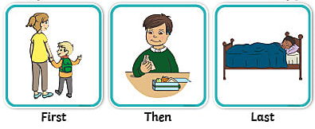 | Date:  Comments: | Learn some nursery rhymes by memory like they did in Victorian Schools.  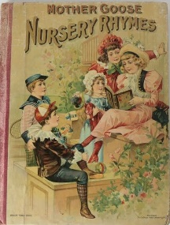  Ask an adult to record you performing them and email it to the office to pass onto your class teachers. Or ask your class teacher if you perform to the whole class. Remember to speak loudly, clearly and expressively. | Date:  Comments:
  Write a book review about a book you have read recently with animals in it. Think about why you do or don’t like the story, who your favourite character is and what the animals in the story are like.  Year 1 use capital letters and full stops.  Year 2 use conjunctions in your writing. | Date:  Comments: | Star Numbers - how many ways can you make a number? Choose a 2-digit number and write it in your homework book. How many calculations can you think of to get that number as your answer. For example, with the number 12, you could have 10 + 2, 20 – 8, 6 + 6, etc. You could repeat with different numbers too!  Year 1 add.  Year 2 add and subtract. | Date:  Comments: | Make a Bird Feeder  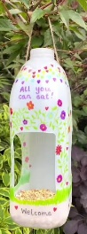  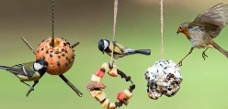  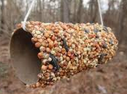  Use the internet to find a way of making a bird feeder. Take a photo of it in your garden and see how many birds come to visit! | Date:  Comments:

