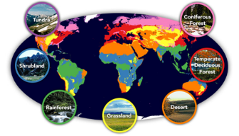
Willow Homework Grid: ‘Biomes’
I I did this independently with no help.
S I did this with some support.
H I needed lots of help and found it tricky.

Please choose one activity a week, and record which activity has been completed by adding the date into the box provided. Please add comments, should you wish to,
regarding your child’s engagement/enjoyment/understanding of each activity. Please choose at least two from each column during each half term.
English |  | Maths |  | Topic/Creative
Reading:  In your reading book, find descriptions of settings. Can you spot the following features? You can note down the most effective descriptions.  - -description of the landscape  - -atmosphere description (mood/time of day/light/dark/season/weather)  - -sensory description (sounds, smells, touch, tastes, sights, feel of a setting)  - -setting descriptions that show the character / action  - -expanded noun phrases  - -super synonyms / adverbials / adverbs  - -figurative language such as similes, metaphors, alliteration, personification, etc | Date:  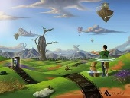  Comments: | 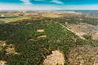  Calculations:  Solve the following worded problems and show your workings out.  A. In 2021, 13,235sq km of forest was lost in Brazil, 4876sq km in Bolivia and 8975sq km in Indonesia. How much forest was lost in these countries?  B. 4578 square km of rainforest is lost a year to logging. How much is lost after 17 years?  C. 7892 square km of forest land is needed for farming.  How much loss will there be across 38 forests?  D. 6784 pieces of plastic were found on 78 shores.  How many pieces of plastic were found?  E. It costs £9 to plant a tree. How many trees can  be planted with £3651? | Date:  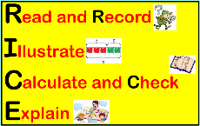  Comments: | Science activity: Choose your own activity!  1) Create your own biome diorama / collage / 3D model. Find out the climate, biodiversity and landscape of your chosen biome and then show  this in your project. Try to use junk materials.  2) Invent and design your own rainforest animal.  Draw or make your animal and write a  description of it. Think about what it looks like, where it lives, what it is like, what it eats (food chain), whether it is prey or a predator and to which animals.  3) Find out about the habitats around you (your garden, under logs, in the grass, in the trees, or in your local woodlands area). Take photos of the creatures you find and then write down what animal group it belongs to. | 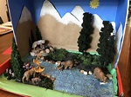  Date:  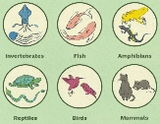  Comments:
Writing: TO DO AFTER WEEK 5  - Should we ban all plastic?  - Should all deforestation be made illegal?  1) Pick one of the questions above and write some ‘for’ and ‘against’ reasons. You may need to do some research to find out the positives and negatives for the issue.  2) Then, write a balanced argument on this topic using the following structure:  a) Introduction  b) ‘For’ points  c) ‘Against’ points  d) Conclusion  3) Use formal, persuasive and emotive language to convince the reader of your argument. | Date:  Comments: | 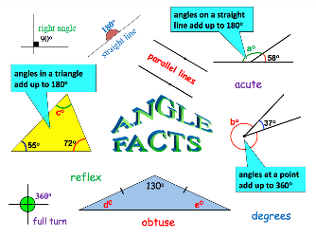  Angles: TO DO AFTER OUR GEOMETRY LESSONS  Make a poster on different types of angles. Use examples to show the angle rules.  a) different types of angles  b) angles on a line  c) angles at a point  d) interior angles of a triangle  e) interior angles of a quadrilateral | Date:  Comments:
 |  |  |  | Geography: Choose your own activity!  1) Draw a blank world map or print one out and then mark the following on your map: Antarctic Circle, Arctic Circle, the continents, the oceans, Northern hemisphere, Southern hemisphere, Tropic of Cancer, Tropic of Capricorn, equator, etc.  2) Draw a blank world map or print one out and then create a colour key to show different biomes.  Research where all the main biomes are and then colour in the different biomes on your world map. | 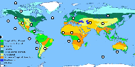  Date:  Comments:
 |  | Shape: TO DO AFTER OUR GEOMETRY LESSONS  Make a shape poster. Draw and label their properties.  For 2D shapes: label the name, number of sides, number of vertices, parallel lines, acute/obtuse/reflex/right angles, regular/irregular, etc.  - Show 3 different triangles.  - Show different quadrilaterals (squares, rectangles, parallelograms, rhombi, kites, trapeziums).  For 3D shapes: label the name, number of faces, shape  of faces, number of vertices and edges, etc.  - Show different pyramids and prisms. | Date:  Comments:
 |  |  |  | Design and Technology:  Design and make a meal/snack that only uses environmentally friendly ingredients. Take a trip to the supermarket or local farm shop and see if you can find ingredients that don’t use plastic packaging. For example, loose fruit or vegetables or ingredients in glass bottles or tinned foods. Write your recipe. | Date:  Comments:
Writing:  Create a poem titled ‘I am a rainforest’. Use descriptive, detailed and powerful vocabulary to emphasise the importance of looking after our rainforests. Use the following website to inspire you: https://www.conservation.org/nature-is-speaking | Date:  Comments:
Spelling Practice:  Our focus this term is to ensure we know the definitions of all the spellings we learn. Please write sentences that include the Y5/Y6 words (definite to frequently). Please learn: definite, desperate, determined develop, dictionary, disastrous, embarrass, environment, equipped, equipment, especially, exaggerate, excellent, existence, explanation, familiar, foreign, forty and frequently. | Date:  Comments: |  |  | PSCHE / Family Discussion activity:  On average each person wastes 500g of food a day! As a family, discuss why food waste is a problem. Think about ways that you can reduce food waste in your home.  Challenge: Can you think of ways you can reduce your plastic waste too? | Date:  Comments:
 |  | Mental Maths: Purple Mash  Complete the two Purple Mash activities on ‘equivalent fractions and decimals’. The tasks have been set as a ‘2Do’ for you. | Date:  Comments:

